AWS(Amazon Web Service) :

Agenda:

1. Introduction
2. What is AWS?
3. What is cloud plateform? Its Advantages
4. Understanding the cource content
5. Target Audience

AWS is not a programming language, it’s a cloud platefrom where the list of services are deployed and these services can be access over the web or internet.

In 2006 Amazon officially launched the Amazon Web Services (AWS) to become a major provider of cloud computing services.

So Amazon Web Services is a collection of remote computing services (Web Services) that together make up a cloud computing plateform offerd over the internet. In short it is a collection of services offered over the web internet. It is very similar to Swiggly which provide the food delevery service over the internet, Ola & UBER transportaion services provide the transportation services over the internet.

In other word AWS is a cloud plateform where a collection of services are deployed and which can be access by the the internet.

It provides all kind of services like:

1. Software as Serivice (SaaS)
2. Infrastructure as Service (IaaS)
3. Plateform as Service (PaaS)

WebSite: http//aws.amazon.com

AWS is locatied in 22 geographical regions. In india it is located in Mumbai.

Amazon Web Services provieds almost more than 100 services.

**What is cloud plateform? Its Advantages**

As the AWS is a cloud plateform, and each cloud plateform promices three concept.

1. **Awailability** : 100 % availability all the time
2. **Scalability** : Ability to grow in size (Instant Elasticity – Scaling up and down)
3. **Pay-As-You-Go** : Low Ongoing Cost, pay as you go , no upfront expences or long term commitment

**Important List of Primary Services frequently used in most of the places:**

|  |  |  |  |  |
| --- | --- | --- | --- | --- |
| 1. EC2 | 1. AS | 9- EFS | 13- SQS | 17- Cloud Watch |
| 1. S3 | 1. VPC | 10- Elastic BeanStalk | 14- SNS |  |
| 1. IAM | 1. Route 53 | 11- Cloud Trail | 15- Cloud Formation |  |
| 1. ELB | 1. RDS | 12- SES | 16- Cloud Front |  |

AWS Certifications : We have following kind and level of certifications.

1. Foundational Level
2. Associate Level
3. Professional Level
4. Speciality

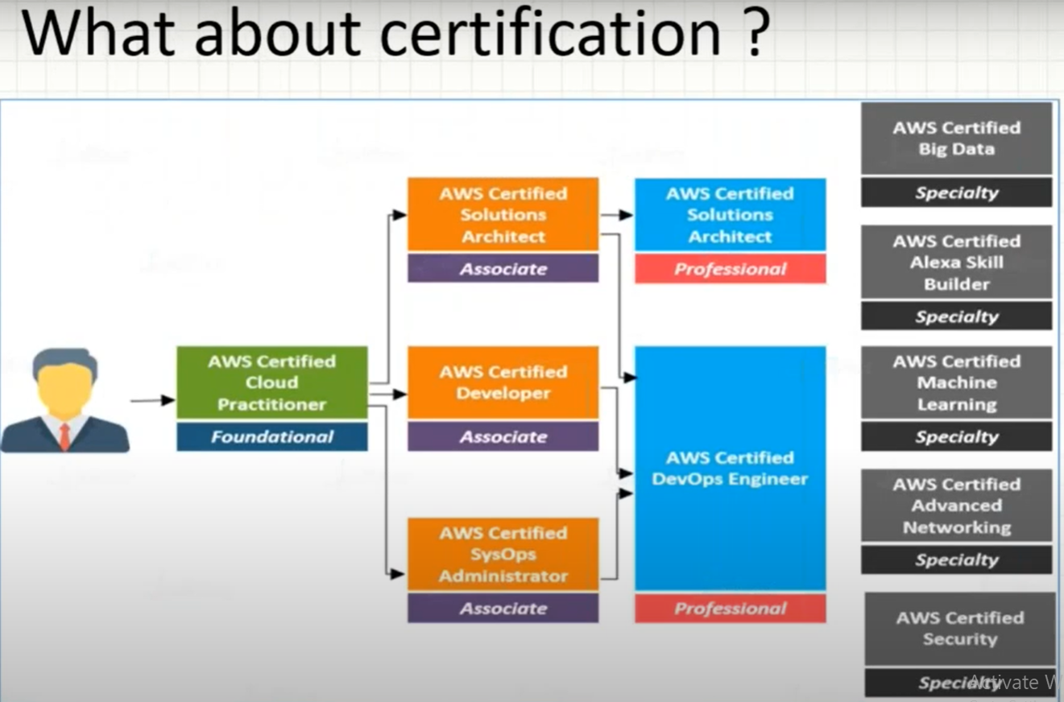

AWS-(Amazon Web Services) : It is a cloud platform where the collection of web services are deployed. These services can be accessed by internet only. It is very similar to Swiggly , OLA, UBER which offer the services through the internet only.

In other word AWS is a collection of services deployed on the cloud plateform and can be offered over the internet.

Agenda:

1. How to create new AWS Account?
2. Understanding EC2 Service.
3. Creating new Windows Machine on AWS.
4. What is Key Pair?
5. Connecting to the remote machine.

This cource is for AWS Solution Architect & Developer Associate Level.

How to create new AWS Account?

If we want to practice AWS or if we want to use the AWS sercices, we need to create AWS account. Since everything is deployed on cloud plateform and can be access accessed over the web that is why we need to create account , unlike if we want to learn java then we need to install java plateform in our machine.

To create AWS account we need the following detail.

1. Email Address
2. Mobile Number linked to bank account
3. Debit Card
4. URL: <https://aws.amazon.com>

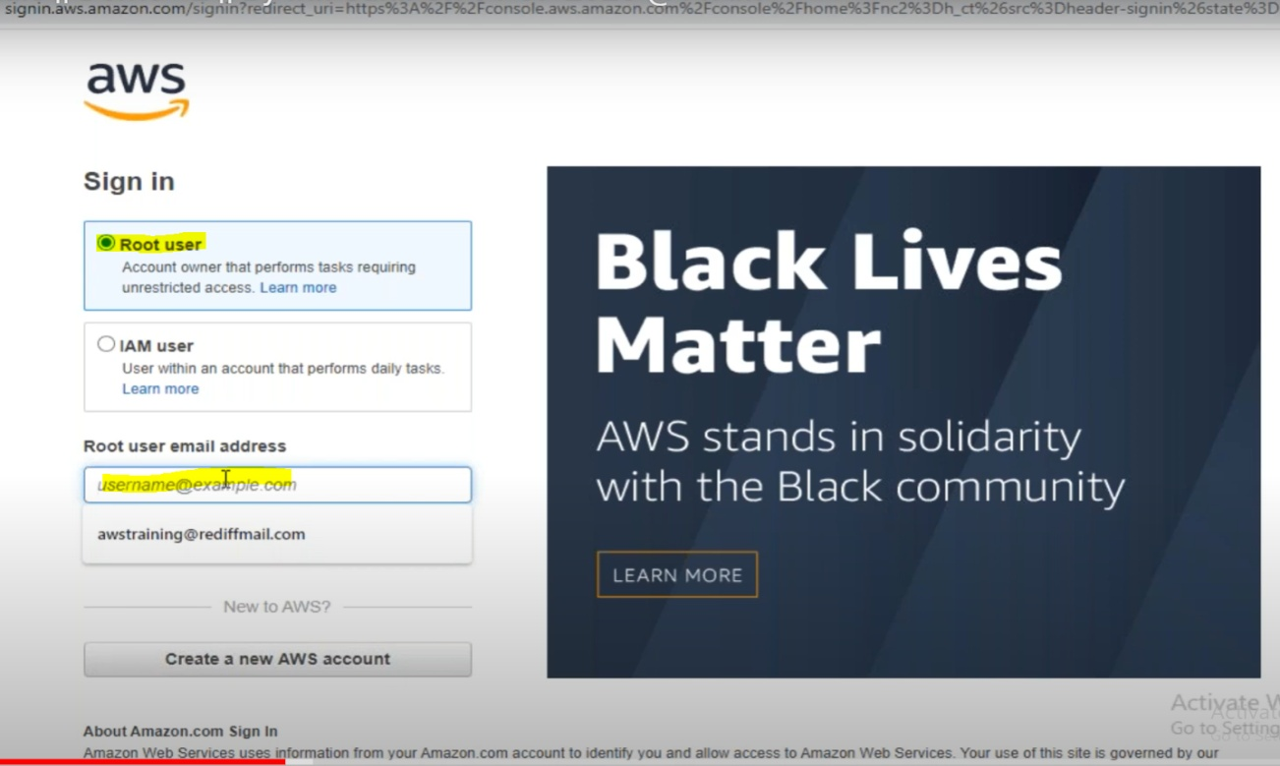

By Default AWS creates Account as Root User.

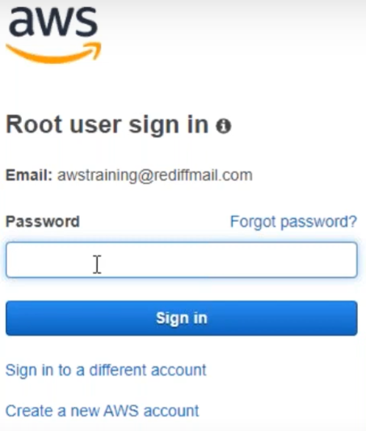

Once we logged in we will get the following screen.

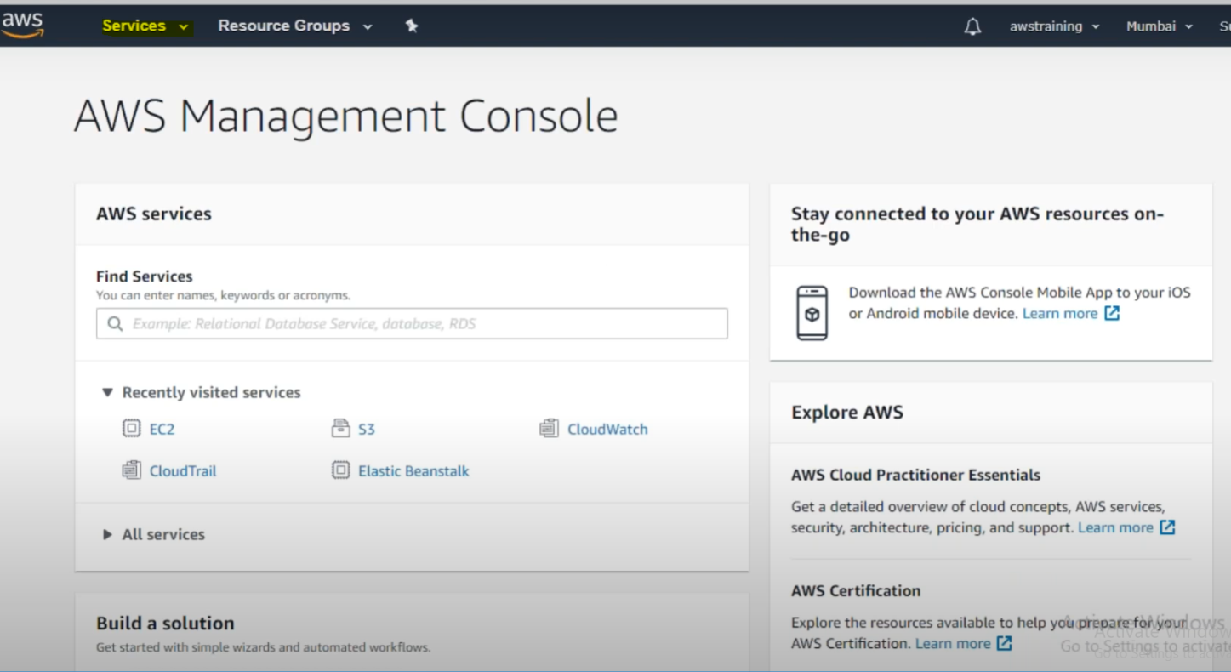

Under Service Tab we will get all the services provided by AWS.

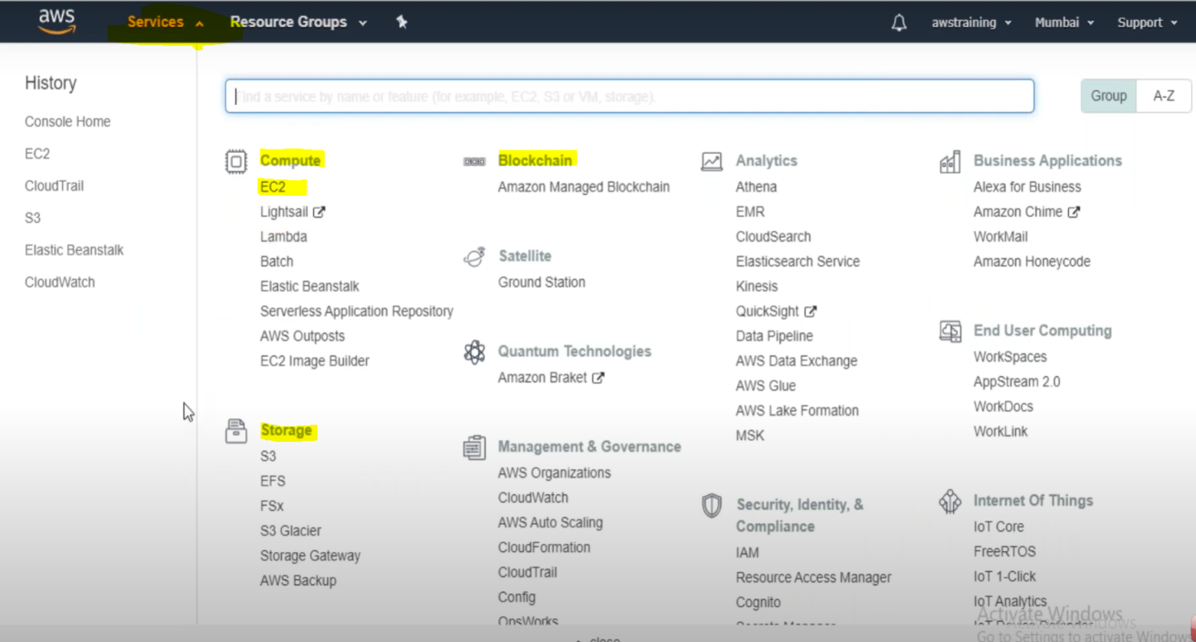

**Understanding EC2 Service:** It stands for Elastic Compute Cloud.

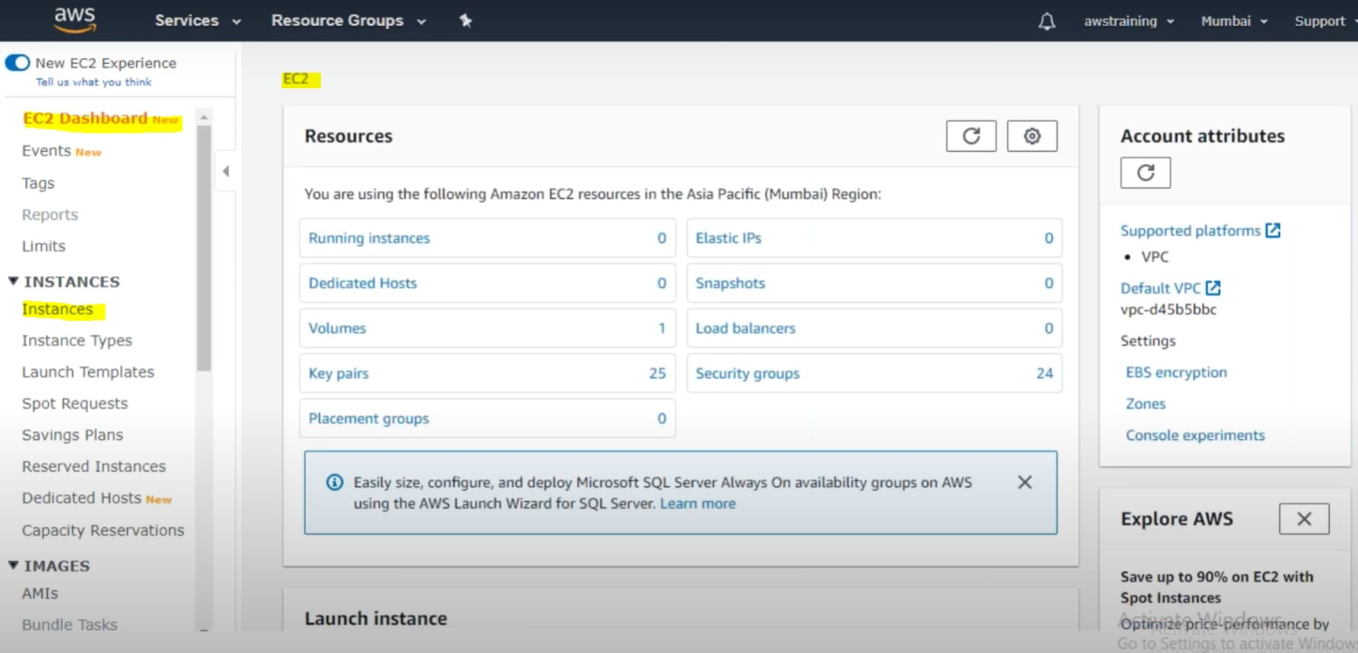

Amazon Elastic Computing Cloud (Amazon EC2) provides sclable computing capacity in the Amazon Web Services (AWS) cloud. Using EC2 we can eleminate invest of hardware up front, so we can develop and deploy application faster.

In short using EC2 we can create instances (Virtual Machine) of the environment like Windows , linux etc in the ASW cloud without having any physical hardware. Here instance as per the AWS terminology could be anything like ( Computer, Machine , Box, PC, Server)

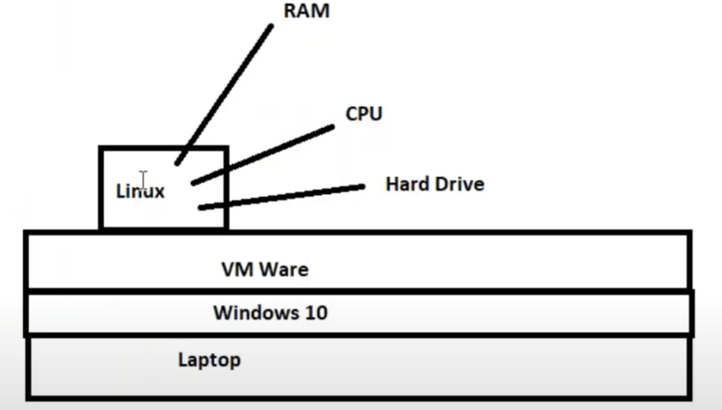

Here in the above example we can see that we have installed Windows 10 in my laptop and in the Windows 10 we have installed VM Ware where in have installed linux. Similarly using EC2 we can create any number of instances in the AWS cloud.

As here we can see that Linux need some size of RAM, CPU and Hard Drive to run the linux machine in the VM Ware, similarly while creating instances in the AWS cloud , we can get RAM , CPU and Hard drive accoding to our requirments.

**Creating new Windows Machine on AWS**

To create instance : Click on instance of EC2 as higilighted in the above screen shot.

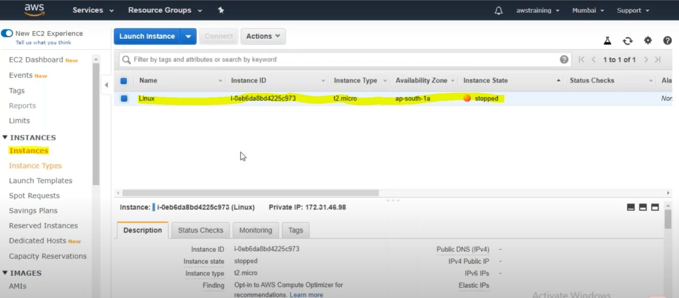

Here we have created one Linux instance as per the screen shot. Now to create new instance click on Launch Instances maked in blue. As soon as we click on Launch Instances :

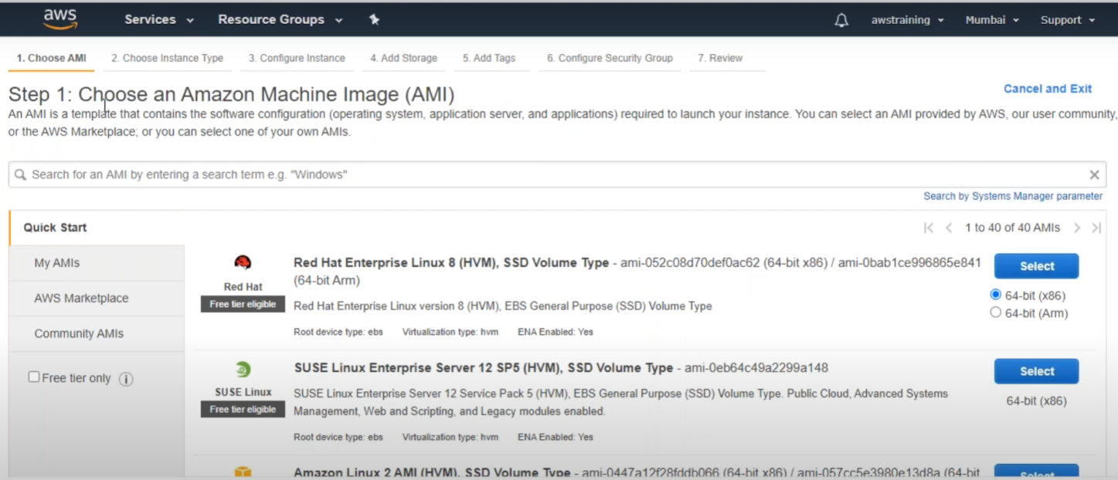

To create new instance we have follow 7 steps as per the above screen shot.

1. Step1: Choose an Amazon Machine Image ( AMI)
2. Step2: Choose Instance Type
3. Step3: Configure instance ( Configuring RAM)
4. Step4: Add storage ( Adding Hard Drive)
5. Step5: Add Tags ( Providing instance –Computer Name)
6. Step6: Configure Security Gropus ( configuring port and other)
7. Step7: Reviwe

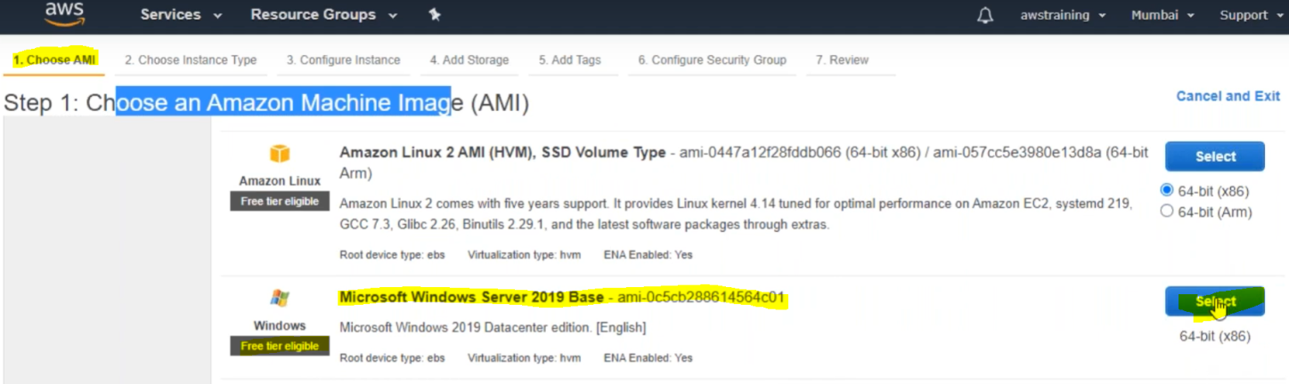

**Selecting AMI means selecting operating system.**

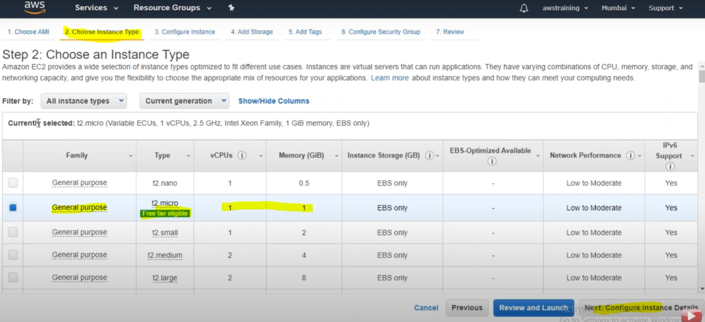

**Here we will get 1 CPU and 1 GB RAM**

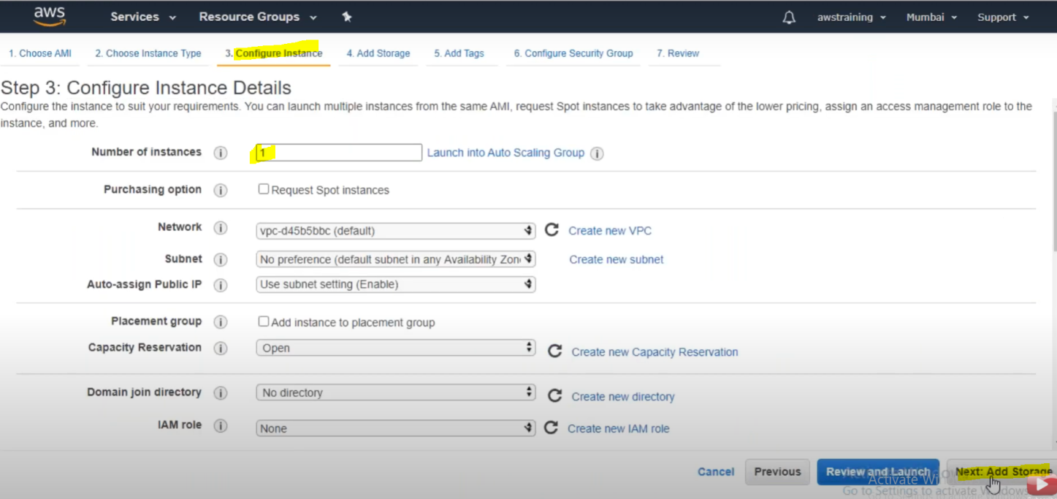

**We have mentioned only one instance:**

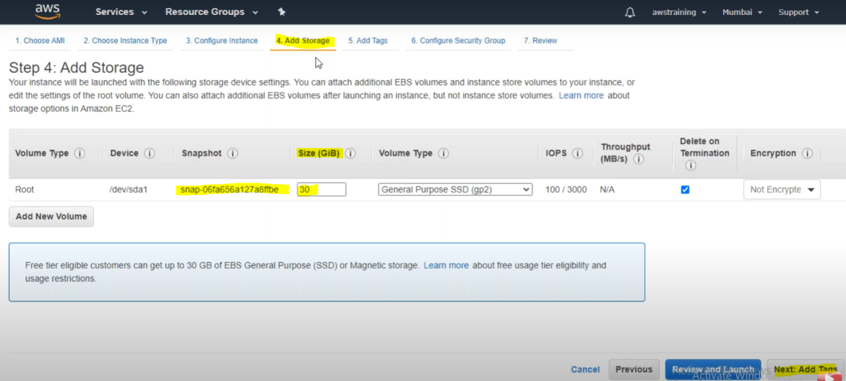

**Here we are getting 30 GB hard drive as storage.**

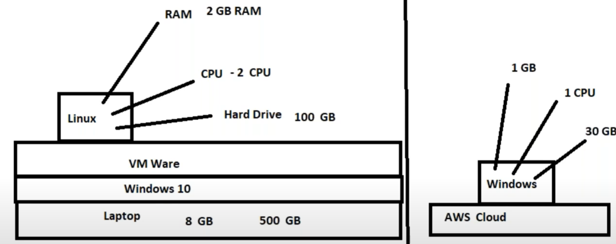

**Similarity : each instance need RAM, CPU and Storage to run in any plateform**

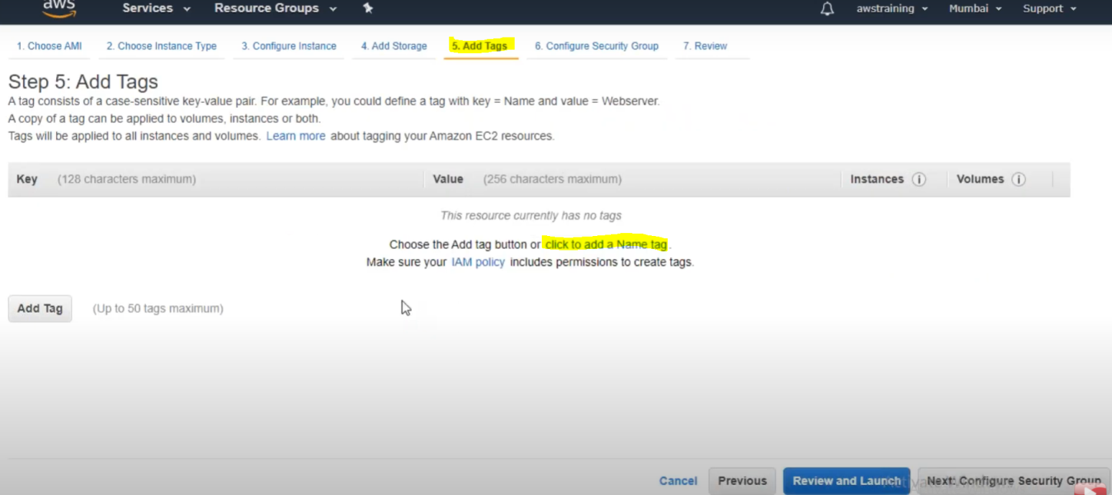

**Click to add a Name tag.**

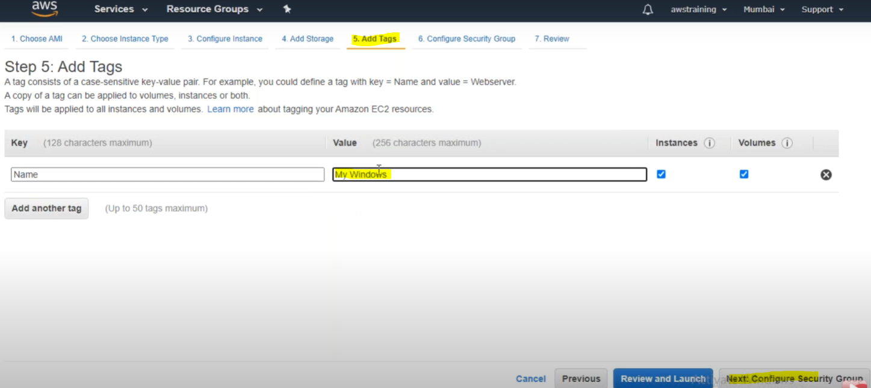

**Provided instance name : My Windows**

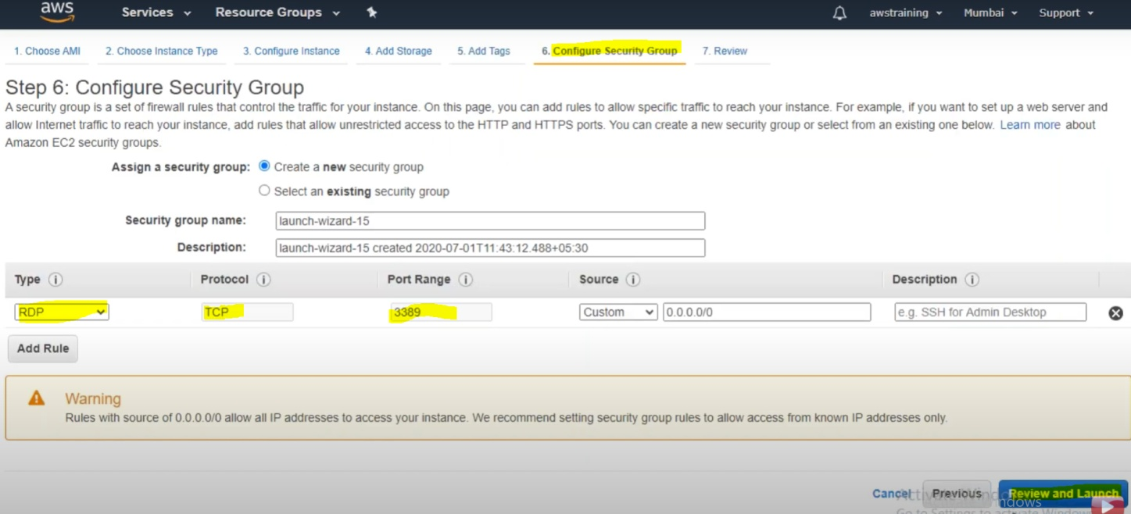

**Finally Review and Launch.**

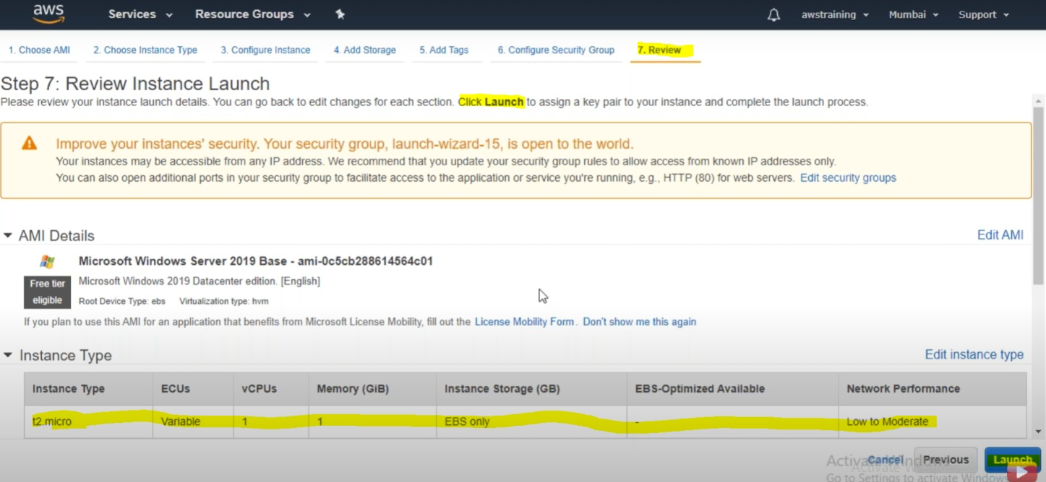 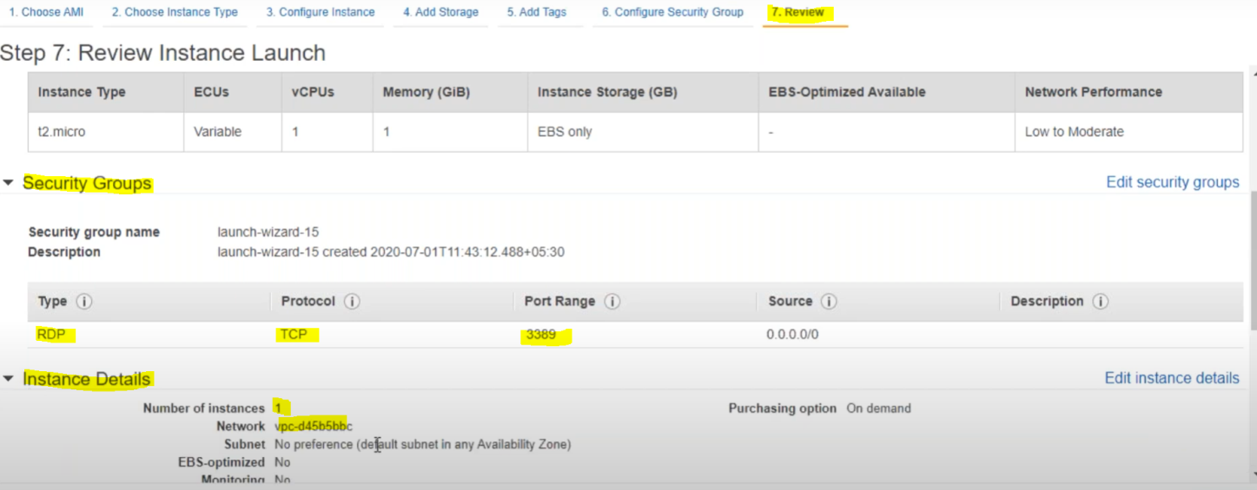

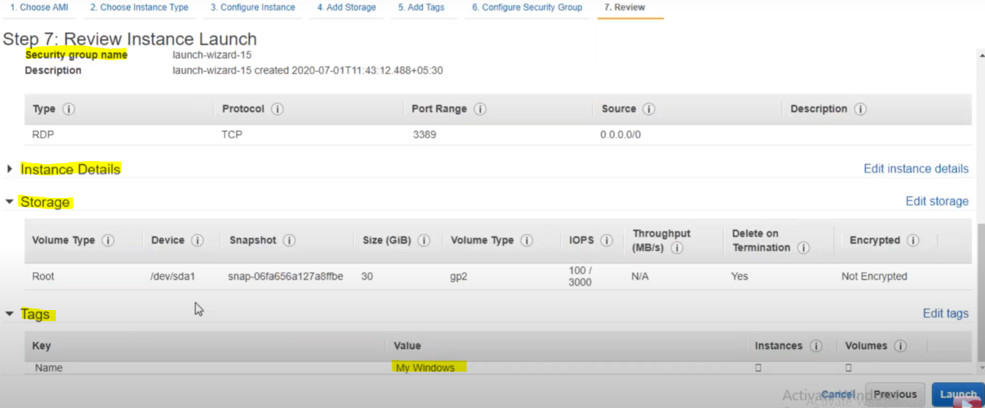

**.PEM File (**Key Pair)

**The moment we click on Launch Button it will as to dwonload key pair file ( having extentation .pem) which will be used to create password to connect with Remote Desktop( RDP)**

**It will ask choose an exiting key pair or to create new key pair . So we will create new key pair.**

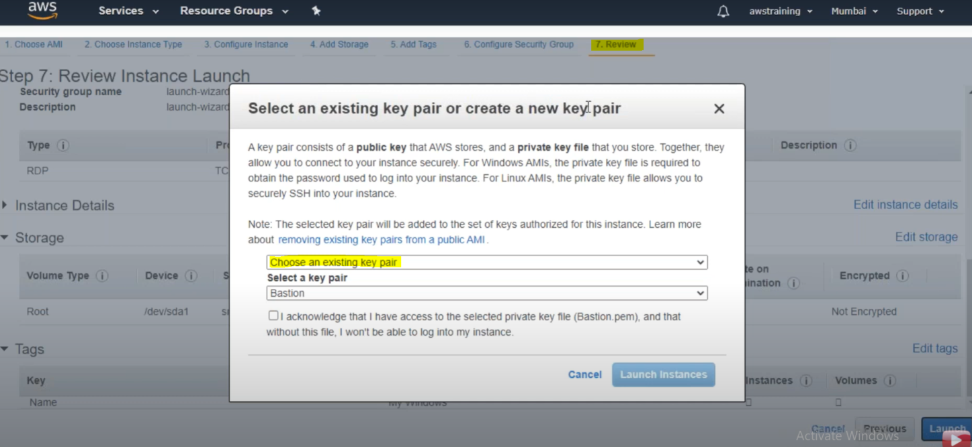

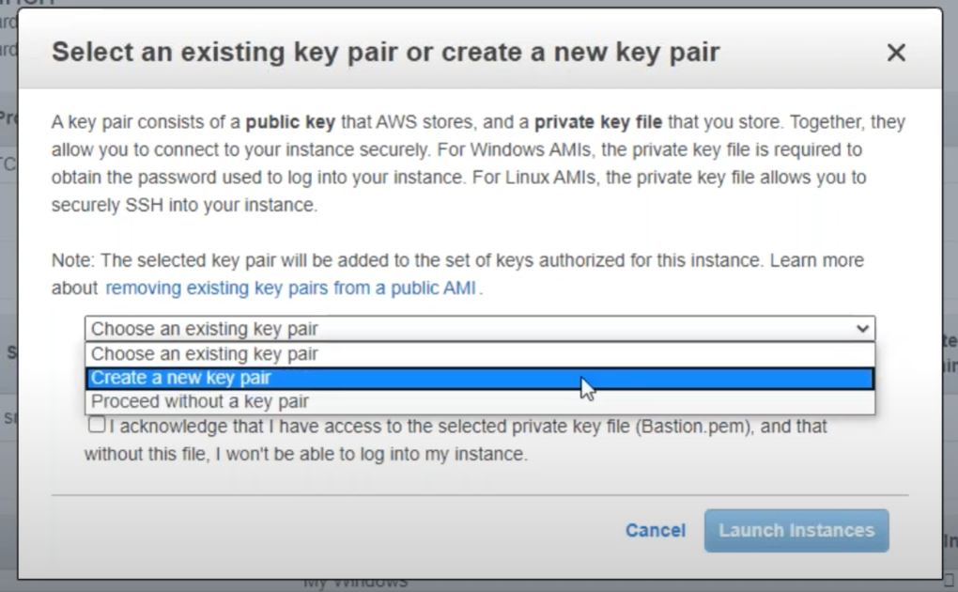

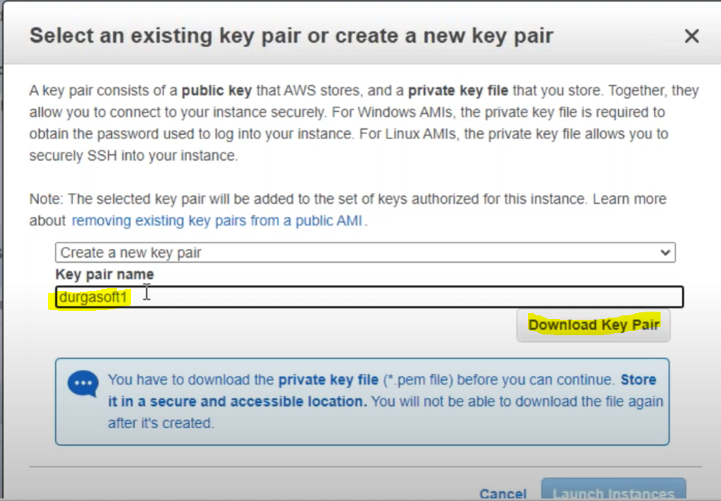

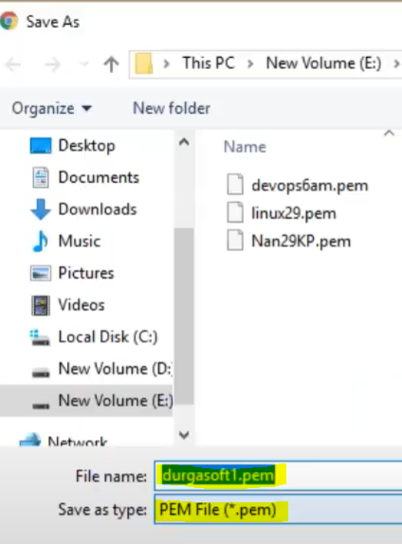

**Now click on Lauch Instances :**

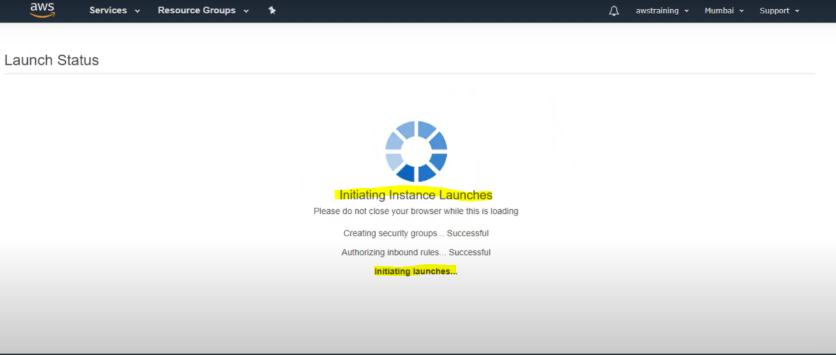

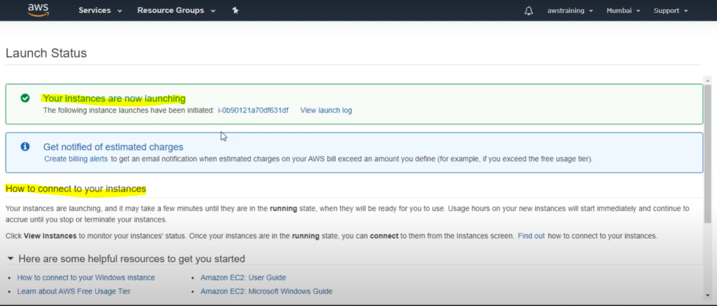

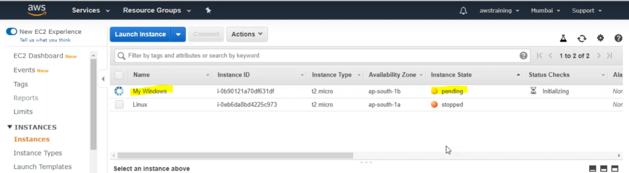

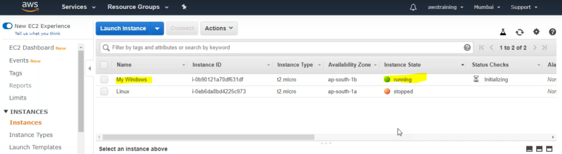

So now we are done with creating Windows machine in the AWS cloud. So next step is to connect this machine with our local machine

**Connecting to the remote machine**

We will connect this remote machine with the help of Remote Desktop Connection available in our local Windows machine .

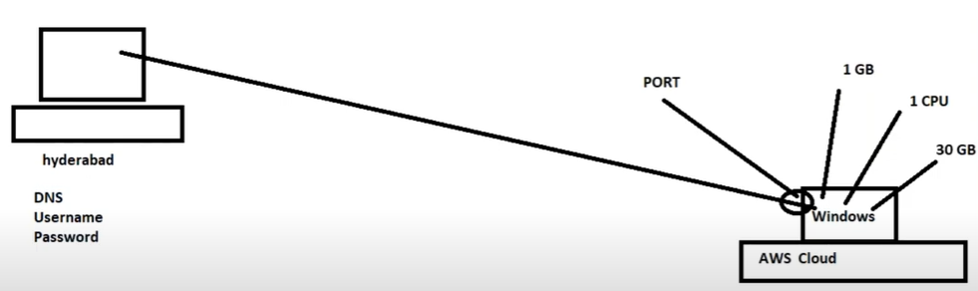

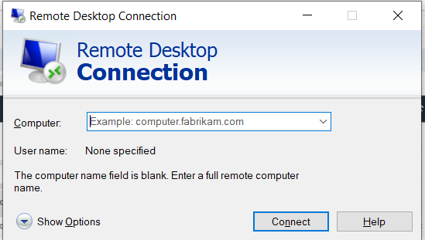

To connect with RDP we need three things : DNS , UserName & Password.

Now to get remote machine DNS, UsereName,Password follow the following steps in AWS cloud.

Step1- Select the created instance and click on connect

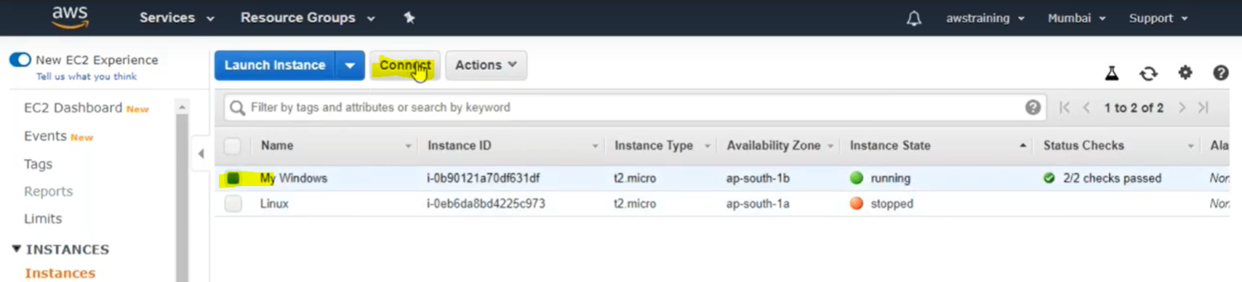

As soon as we click on connect we will get public DNS and username and Get password as per the screen

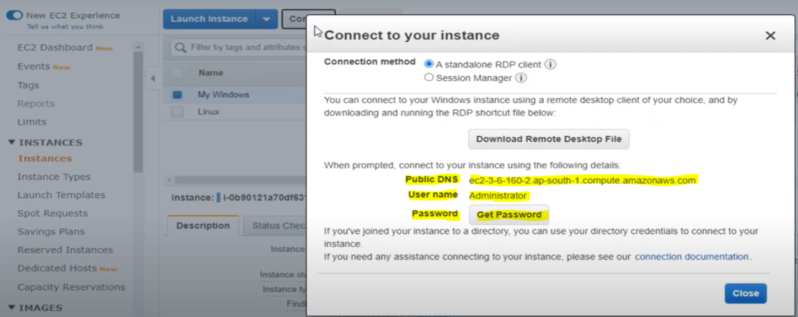

Now we got two credentials (DNS and Userename) now we need to get password. To get password , click on the button [Get Password] and upload the key pair (.pem) file

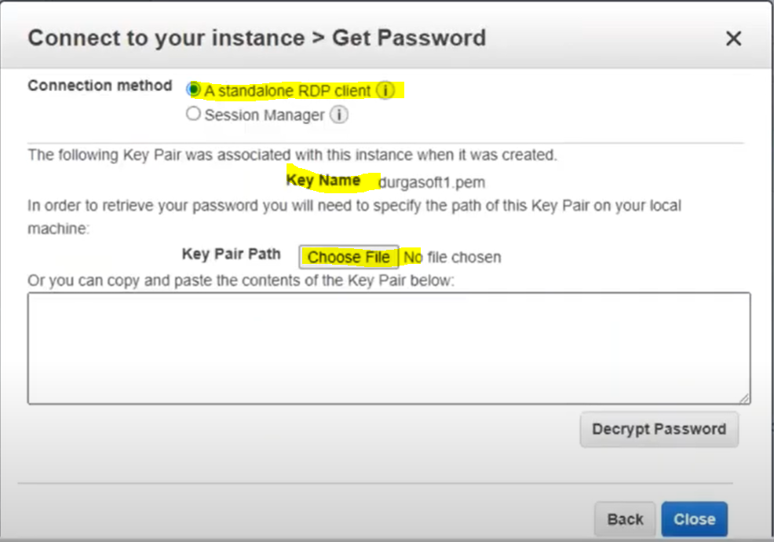

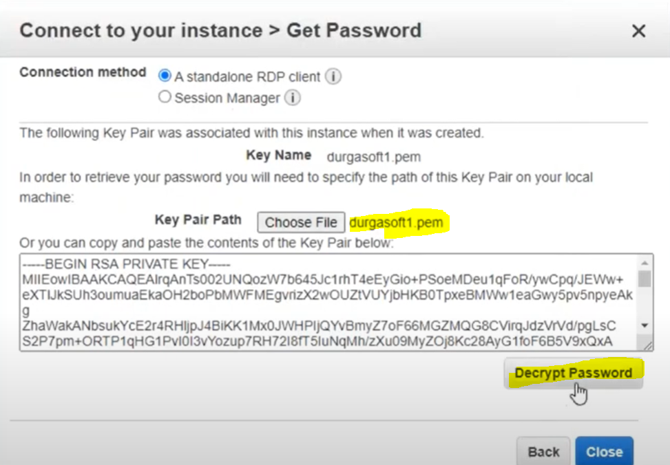

Now after uploading the file click on Button [Decrypt Password]

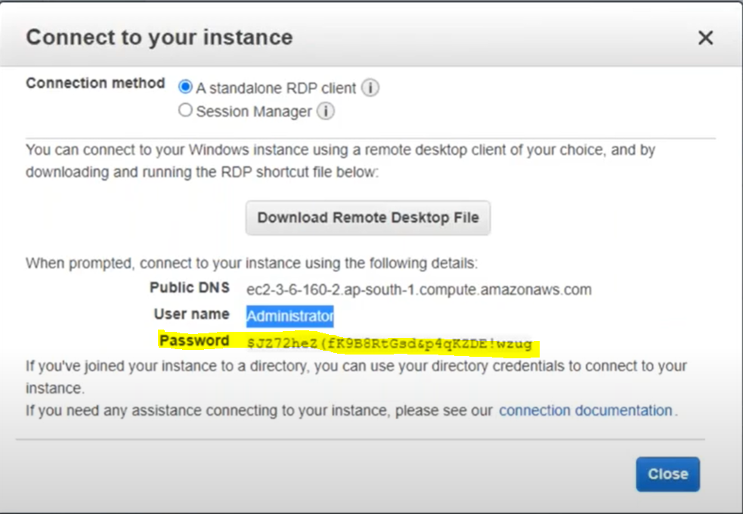

And hence we got the password

Now we got all the credential to connect this remote desktop with our local machine

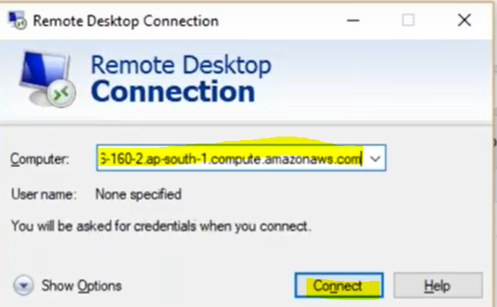

Provide the DNS name and click on Connect

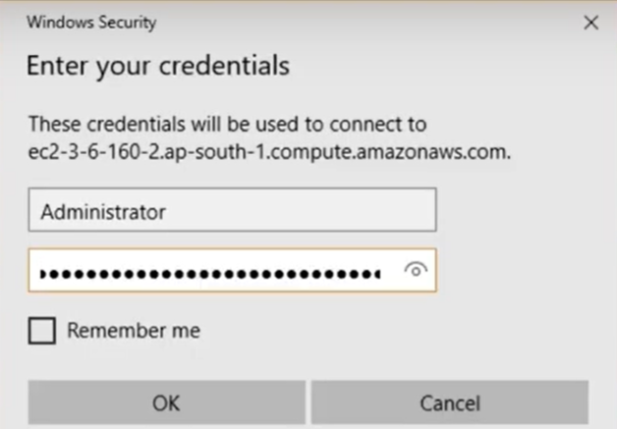

Provide the Username and password and click [OK]

Now the remote desktop in the AWS will start.

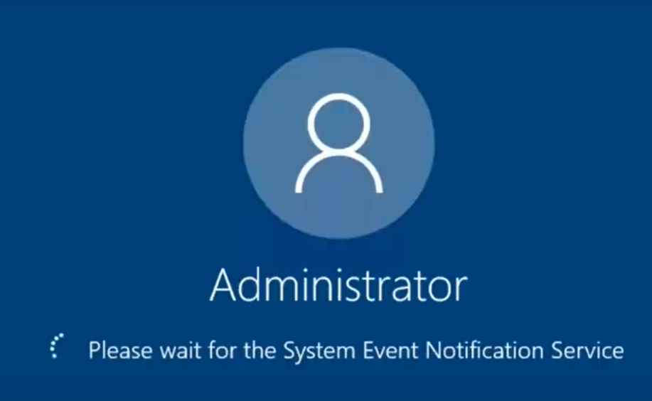

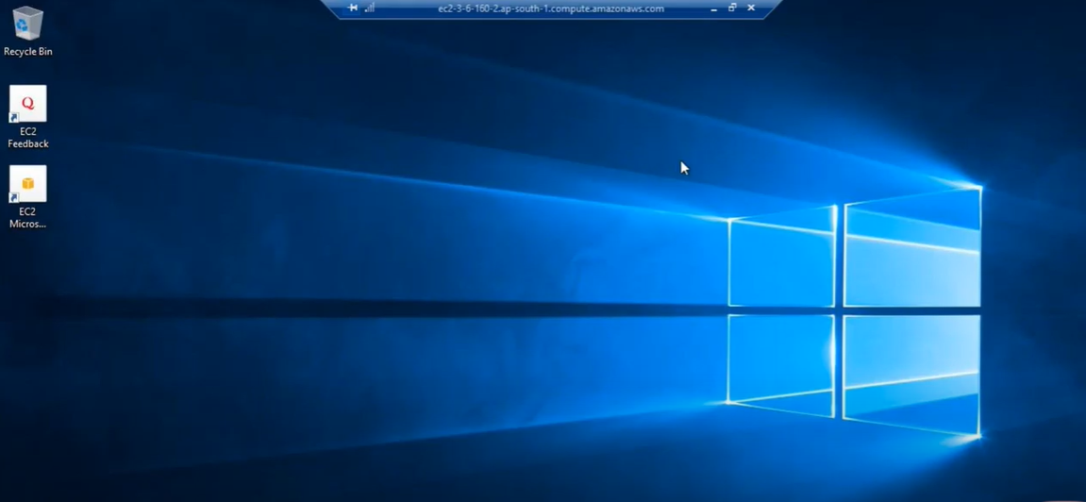

So Finally we got our machine started in AWS cloud.

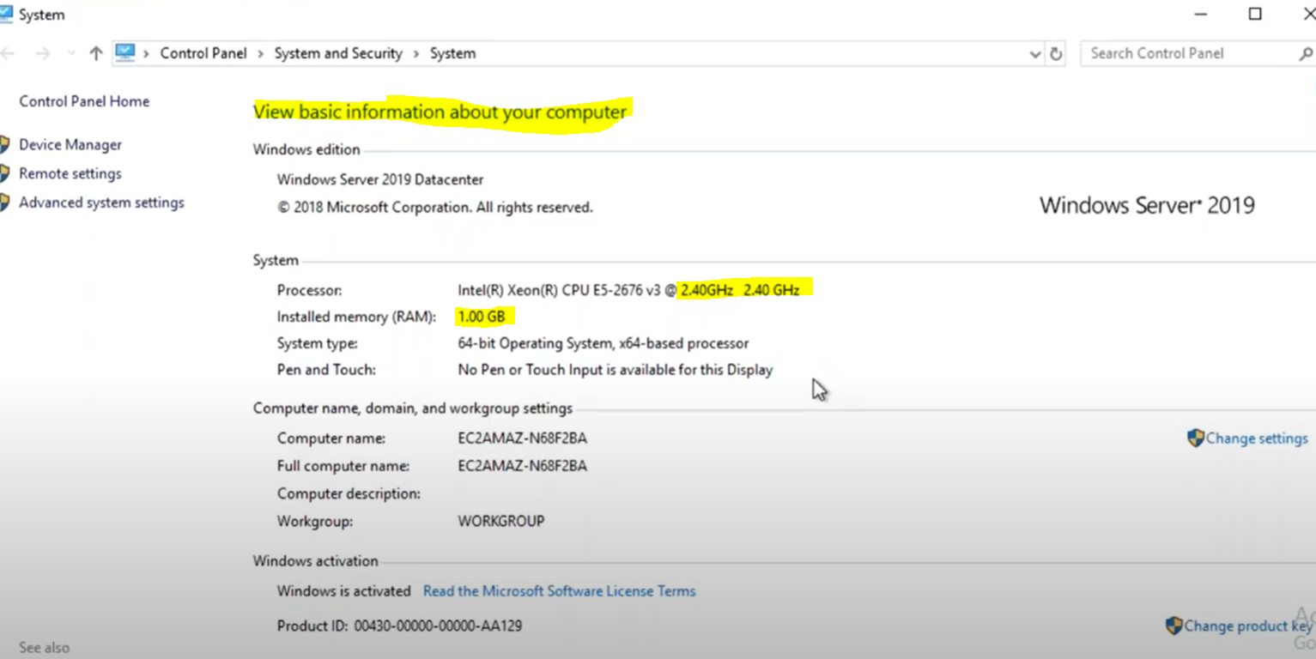

This Hardware is being used in AWS cloud this is not our local machine hardware information.

To shut down or stop remote desktop in the AWS

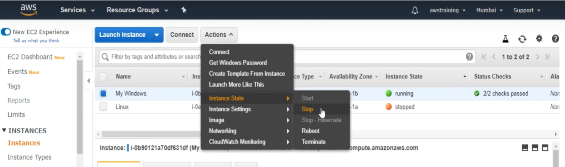

Note : By default AWS provide 300 hrs free to run the machine, and after that it start charging (money) for further use of machine. So its mandatory to stop machine to utilize fruitfully our windows machine in the AWS.

Day-3 – Agenda

1. Creating Linux Machine
2. Understanding Puttygen& Putty
3. Converting .pem file to .ppk file using puttygen
4. Connecting Linux machine with local machine using putty
5. What is WebServer?
6. Installing Web Package.
7. Understanding Security group
8. Opening the http port in AWS to access web page anywhere

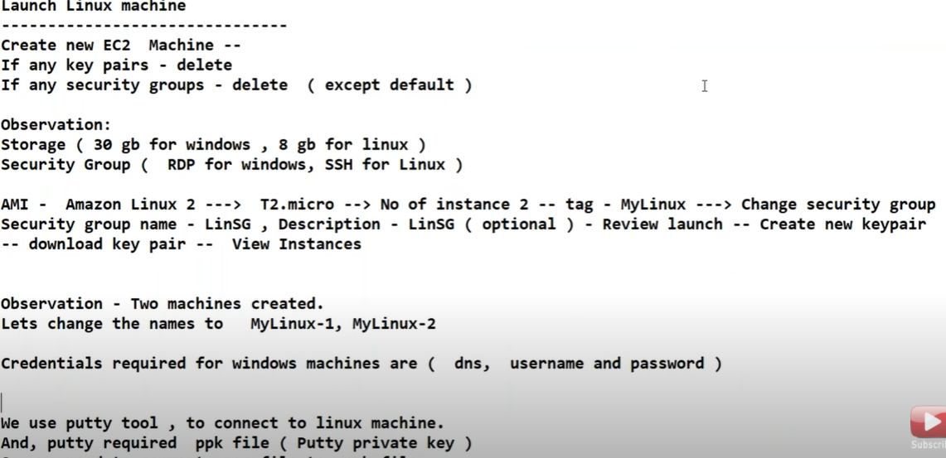

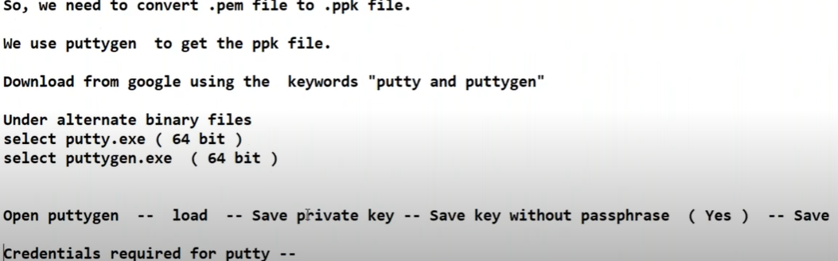

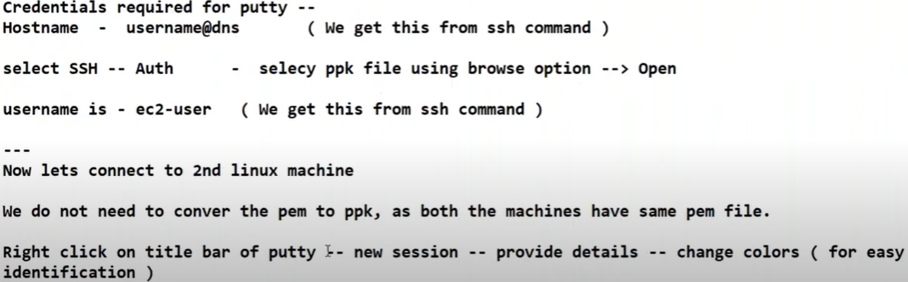

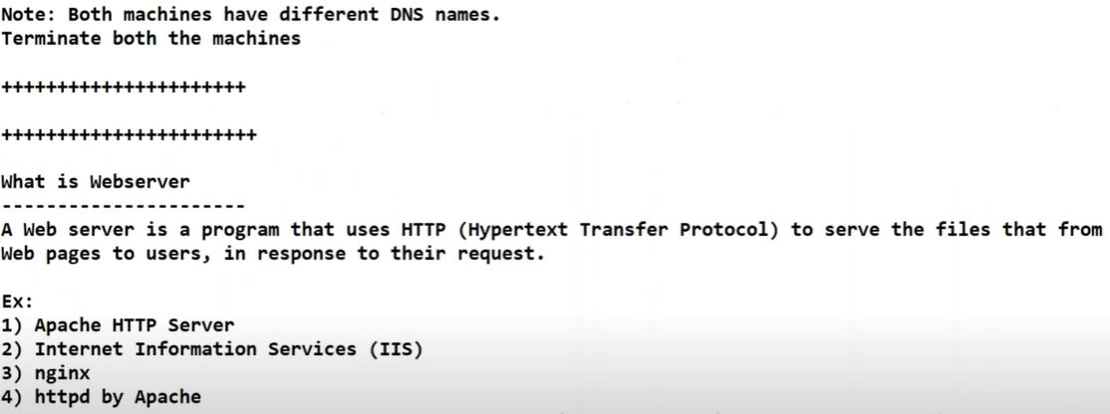 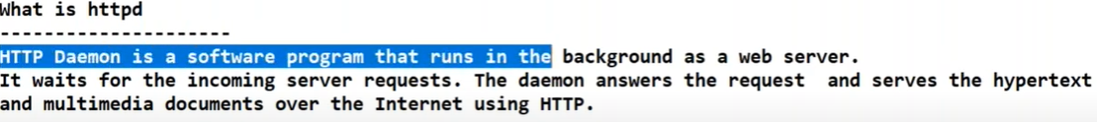 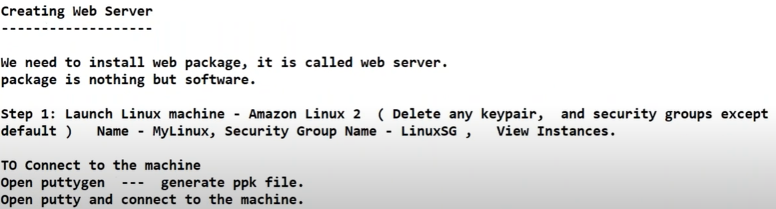

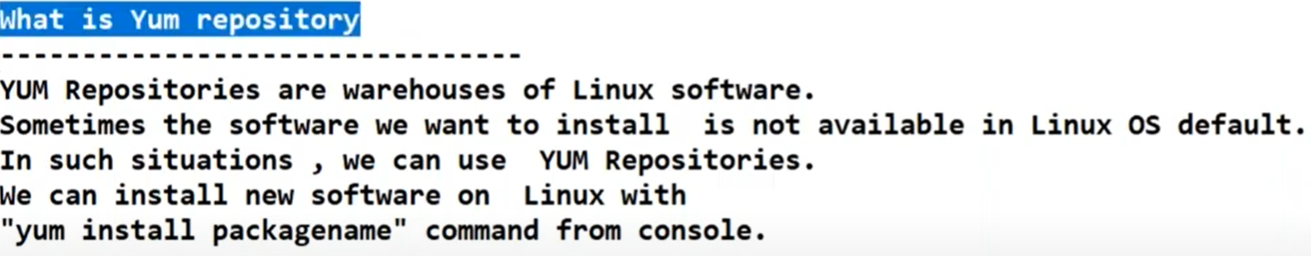

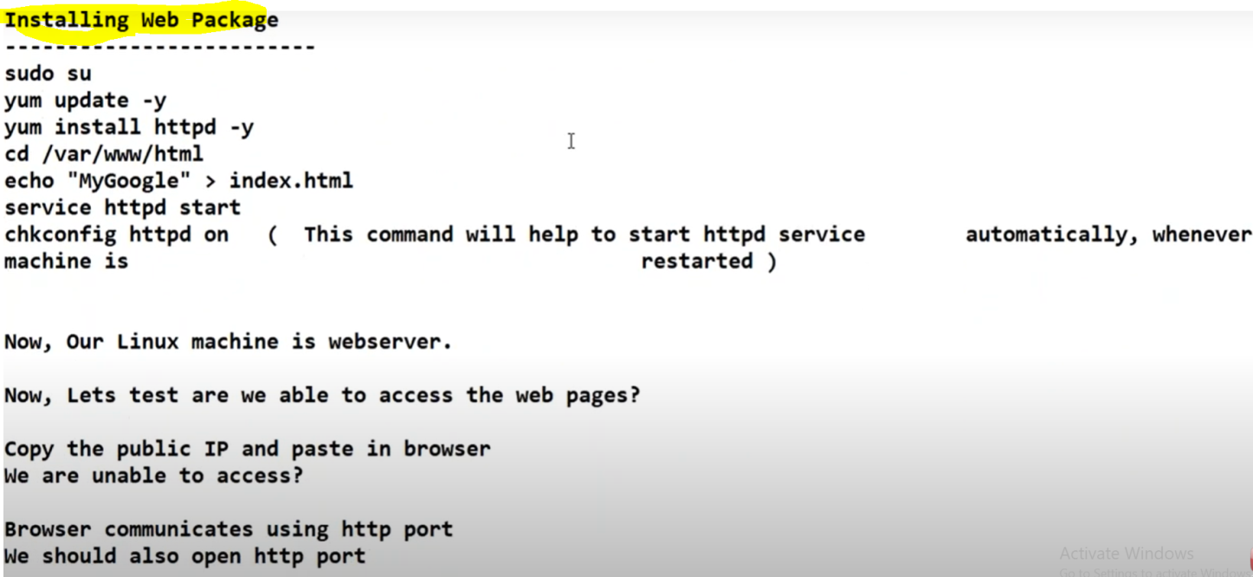

**Creating Linux Machine in AWS:**

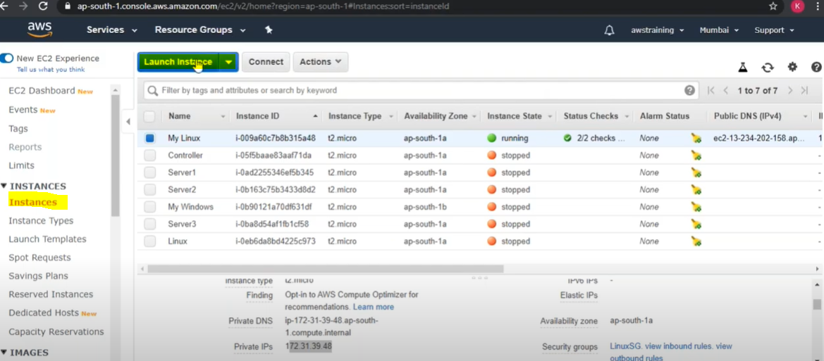 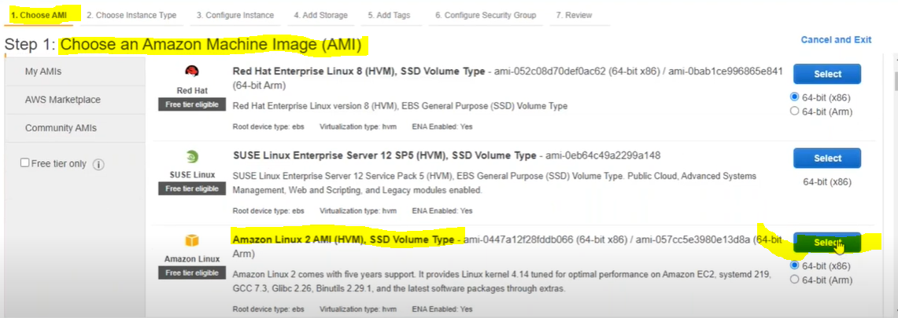

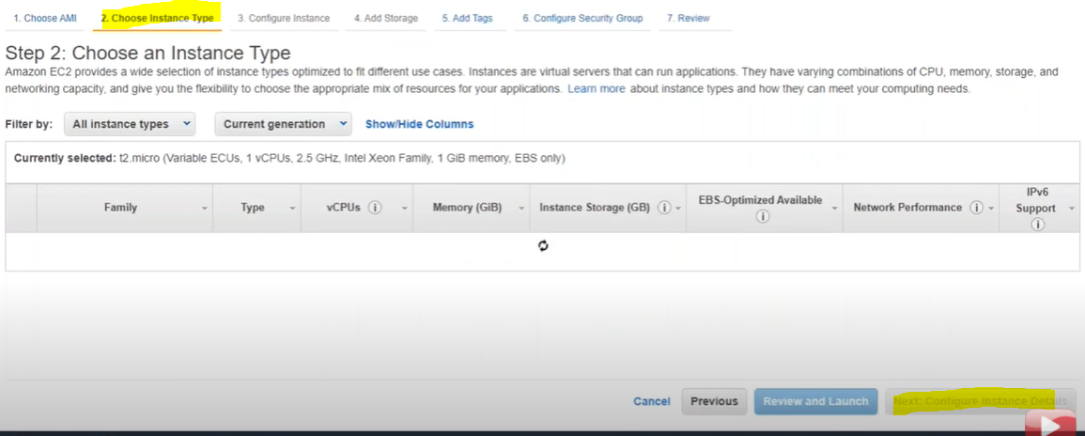 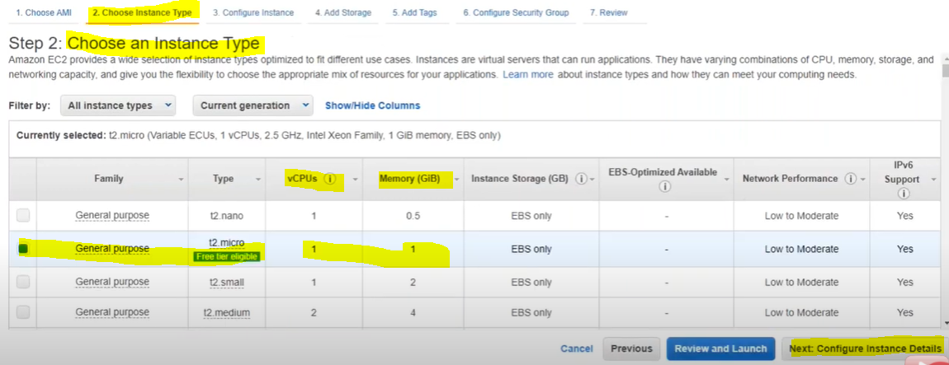 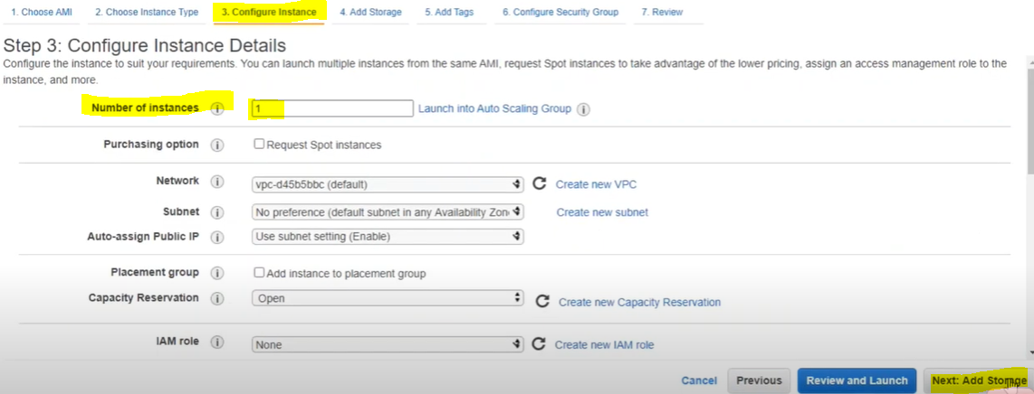 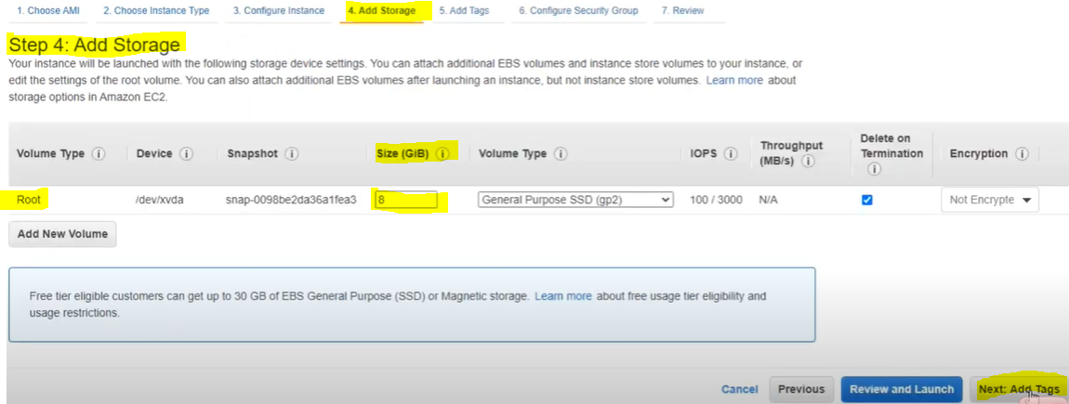 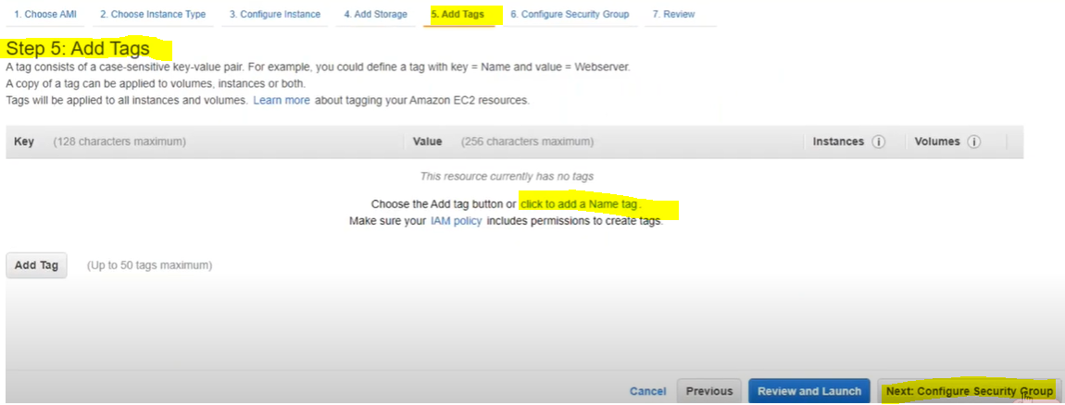 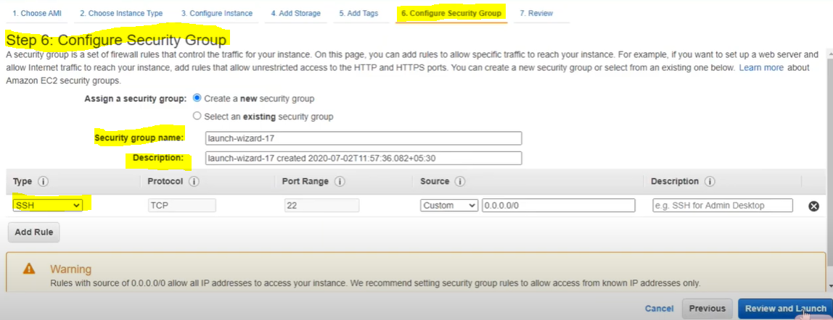

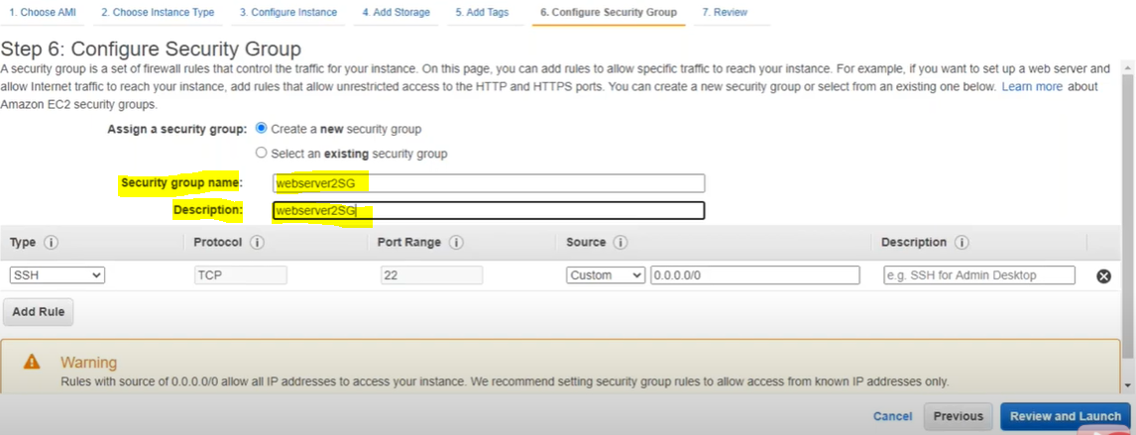 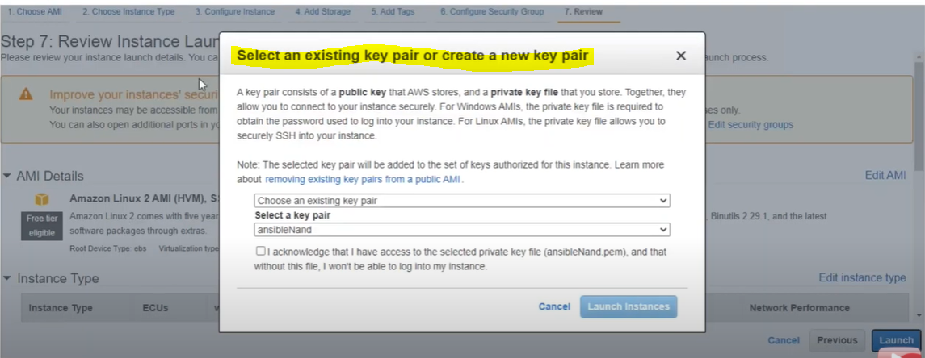 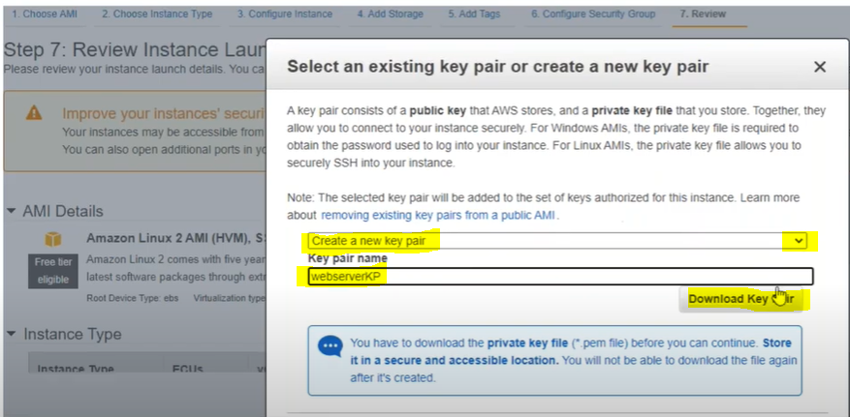

After key pair file gets downloaded , click on launch button

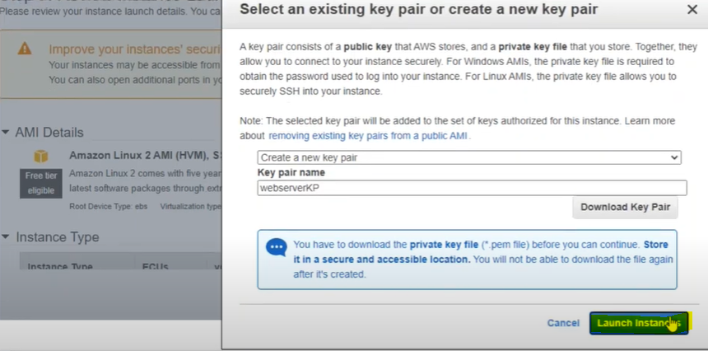 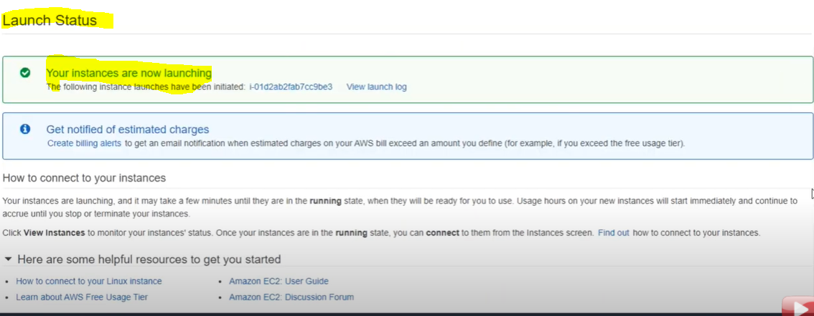

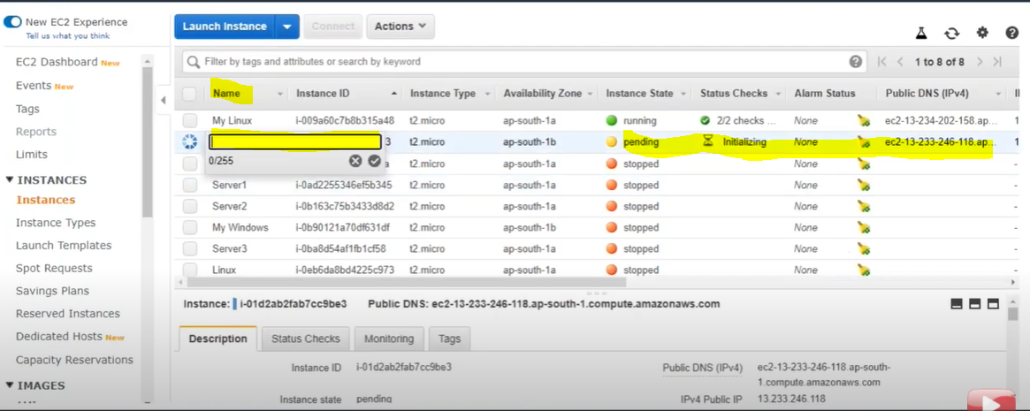

Now provide the Name:

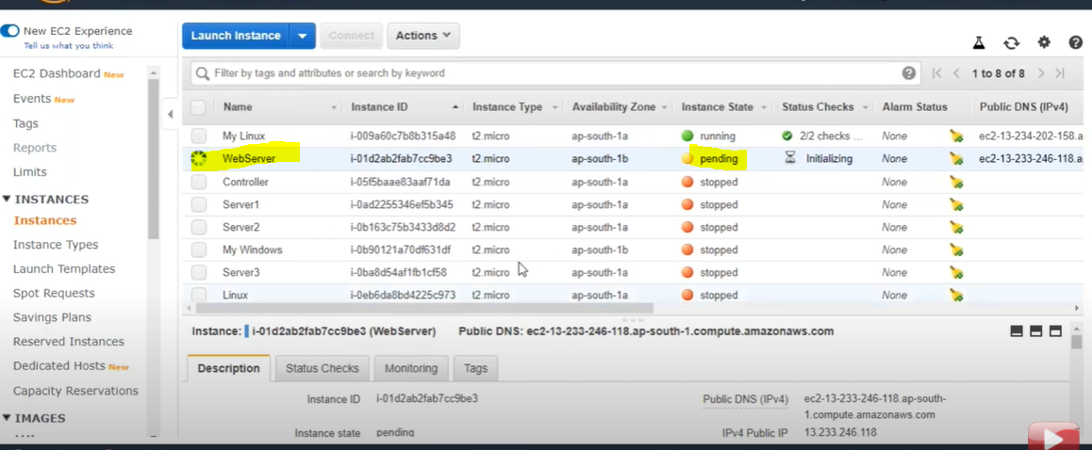

Now connecitn Linux machine with local machine:

First convert .pem file into .ppk using puttygen

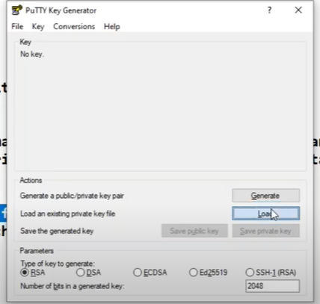

Load .pem file and click on generate

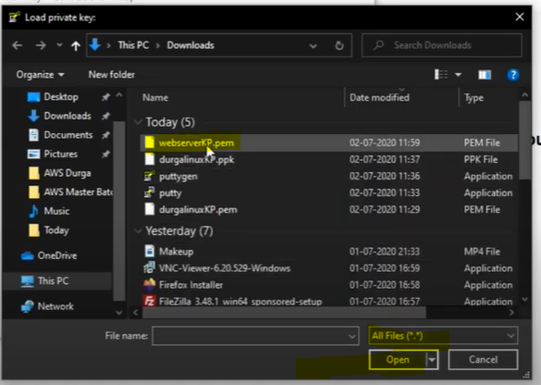

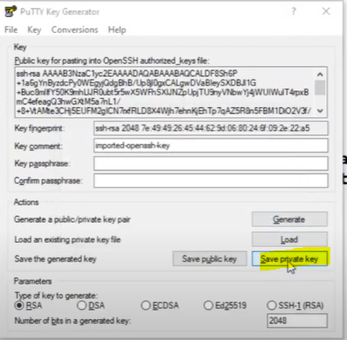

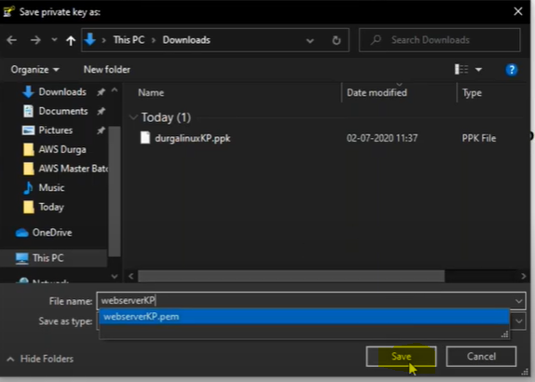

Save without extentaion , it will generate .ppk file and save into this selected location.

Now connect with Linux machine open putty

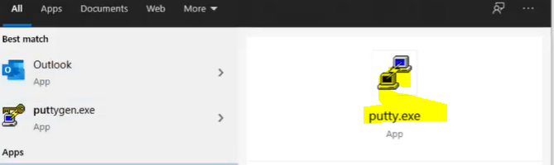

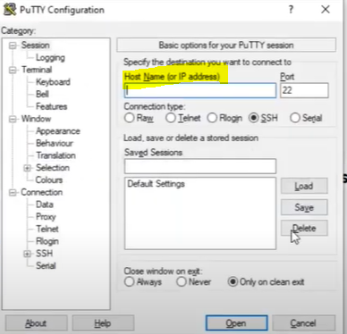

Now connect webServer linux machine in AWS

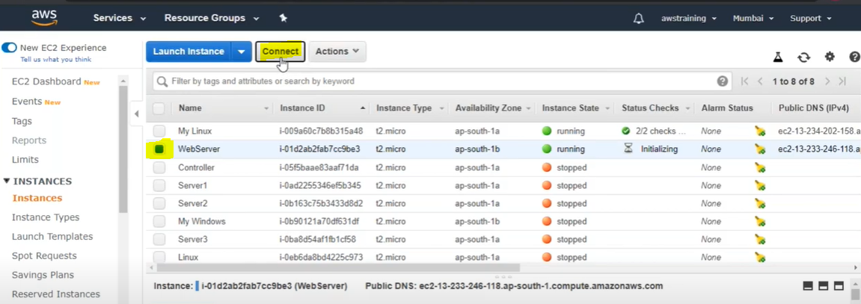

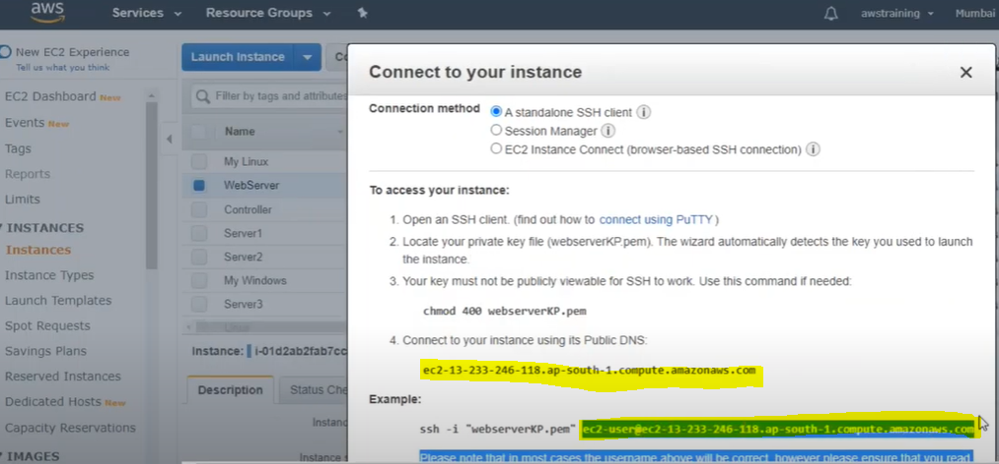

Now we got the DNS

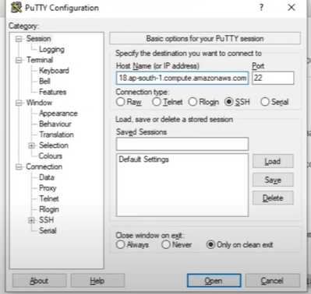

Provide the DNS Name here , select the connection type(port) SSH

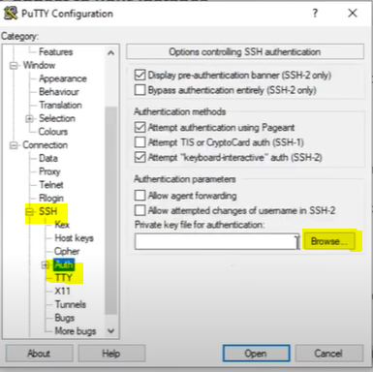

Select SSH > Auth > brows the (.ppk) file

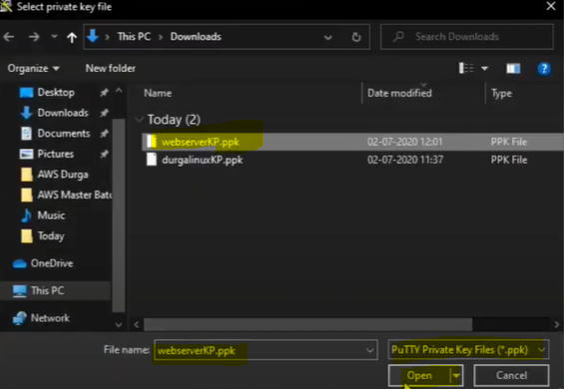

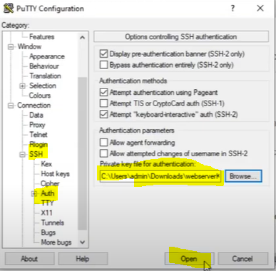

And Finally Linux Machine Got Connected to our local machine

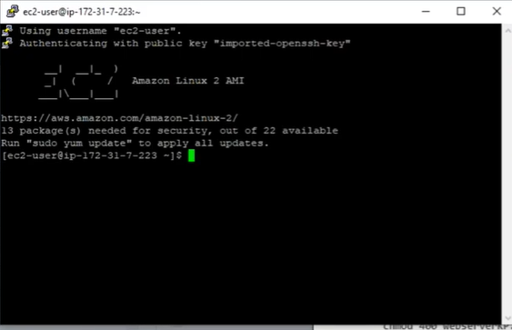

Now linux machine got connected with local machine now Installing the WebServer in the Linux to make it WebServer. We will install Httpd in the linux machine.

Before installing any webserver in Linux let’s have some knowledge about Yum Repository.

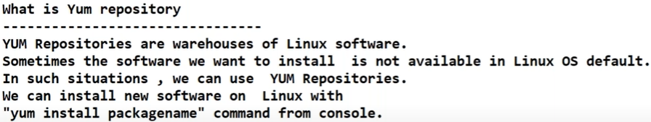

Fallow the following series linux command to install Web Package in the Linux.

|  |  |
| --- | --- |
| #sudo su | // Switching to root user. |
| #yum update –y | // whenever we want to install software first time in the linux then run this command to update the repository |
| #yum install httpd -y | Command to install httpd web server in the linux. |
| #cd /var/www/html | Go to the location where all the html pages will be created |
| #echo “MyGoogle” >index.html | Writing MyGoogle in index.html page. In the above location |
| #service httpd start | Command to start web server |
| #chkconfig httpd on | This command will help to start httpd server automatically whenever machine is restarted. |

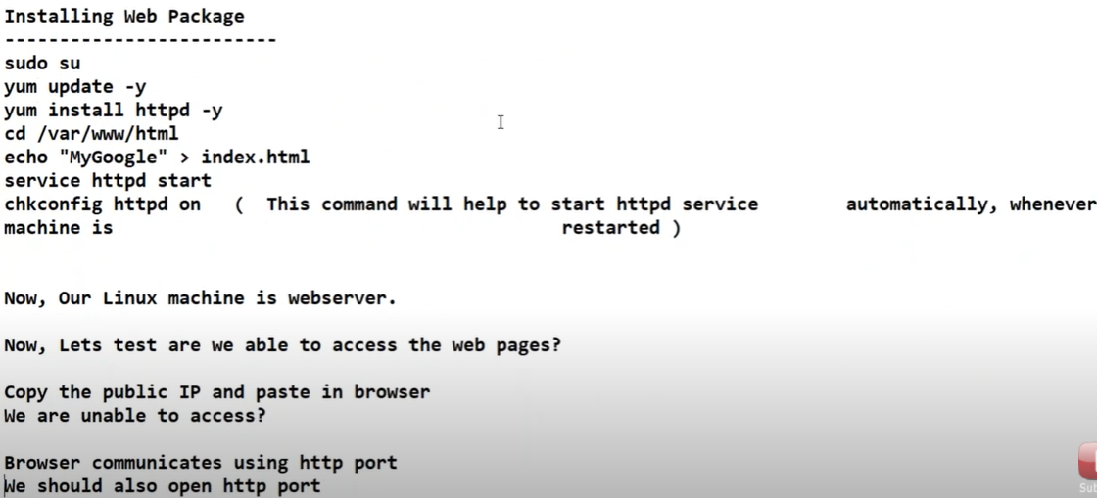

Lets open the http port

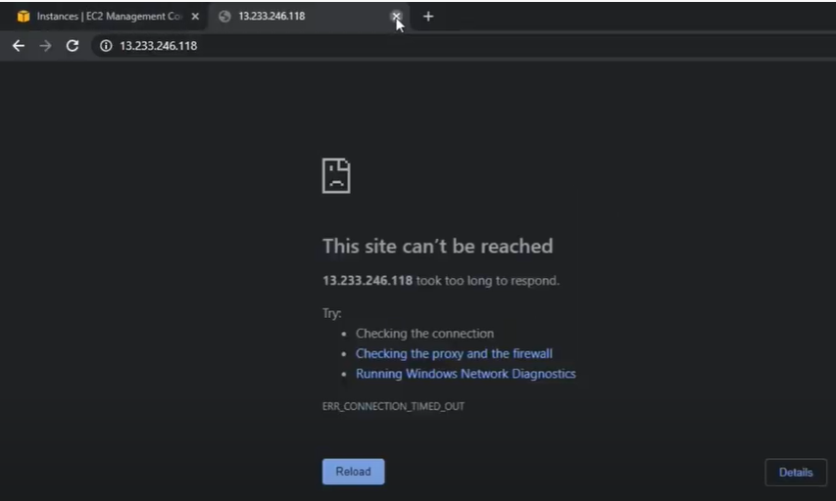

Since as per the webserver concept the web pages can be accessed on http port only and in the linux server we have opened only SSH port only. So to access web page from the WebServer we will have to open http port on the Linux machine.

As in the privious screen shot during Linux machine creation we have mentioned the security group, openting the port is nothing but configuring the security group. We have mentioned the security group with name - WebServerSG

Go to Network & Security > Click on Security Group ( as per the below screen shot)

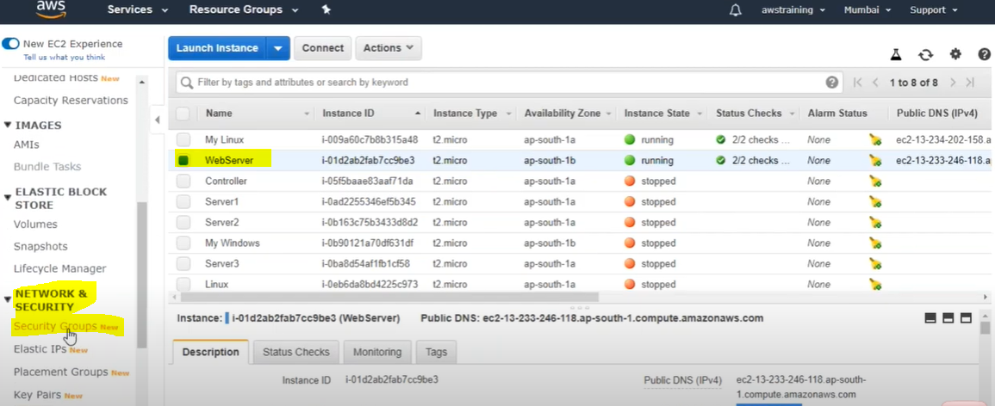

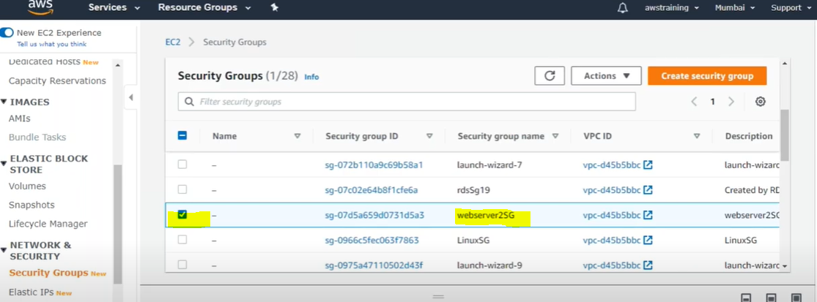

Select the security group > scorll down and go to inbound rule > Click on Edit inbound rules

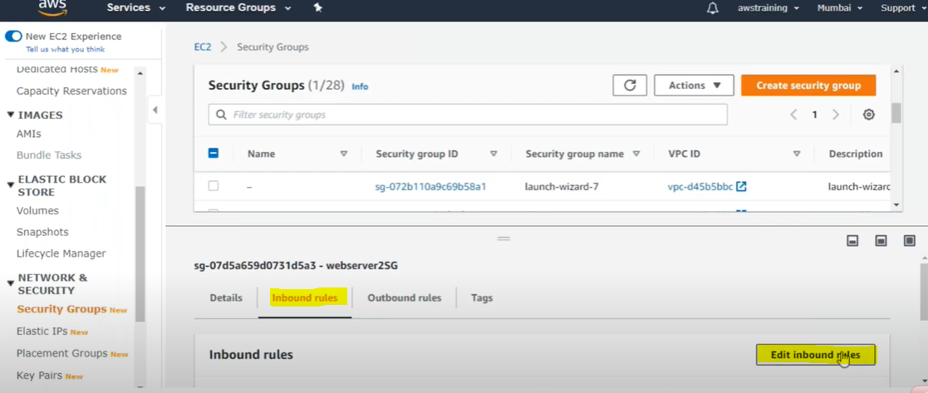

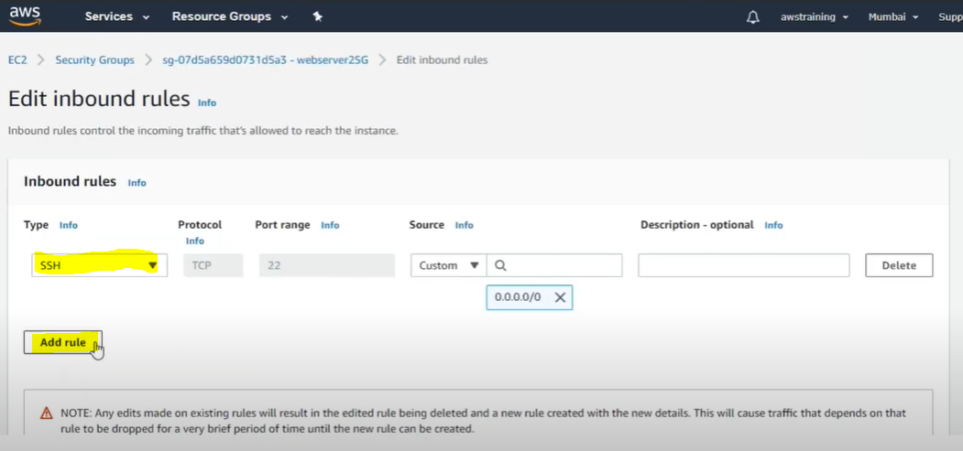As of now only SSH Port is opened. Click add rule button to open http port.

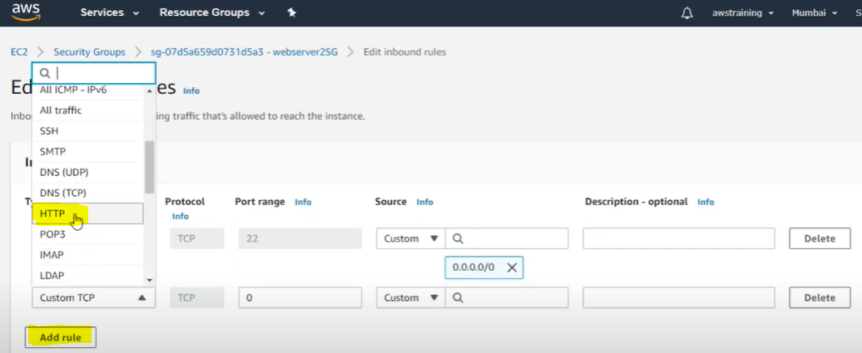

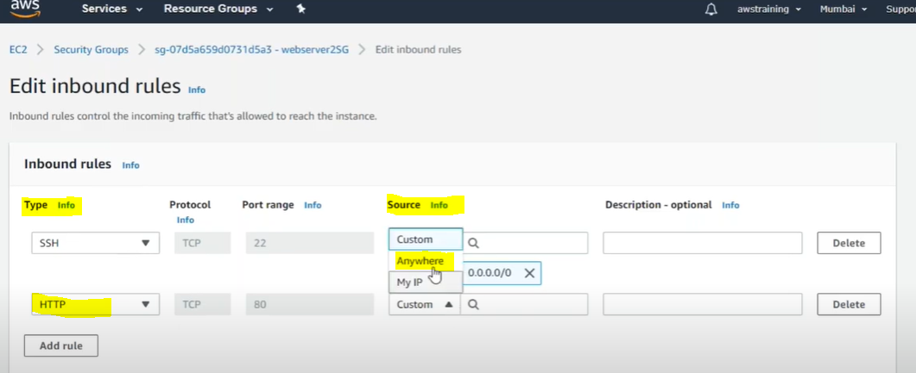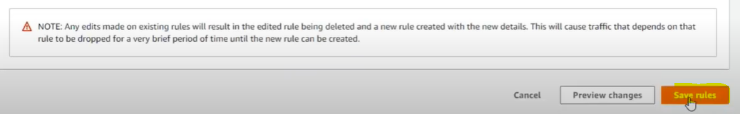

And finally save the rules

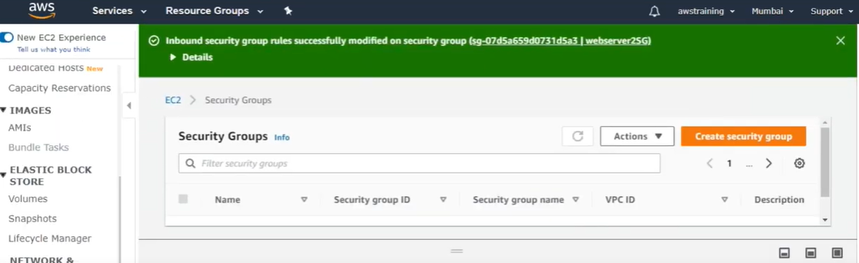

Now take the public ip and run in the browser

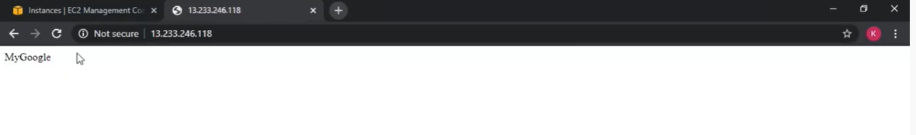

So finally after opening the http port we are able to access we page from the web server.

Note: As we have learnt that once the linux machine gets connected through putty we have to run some mandatory linux command to install webserver on the linux machine. Same command we can mention during the EC2 Machine creating in the step 3 (Configure Instance).

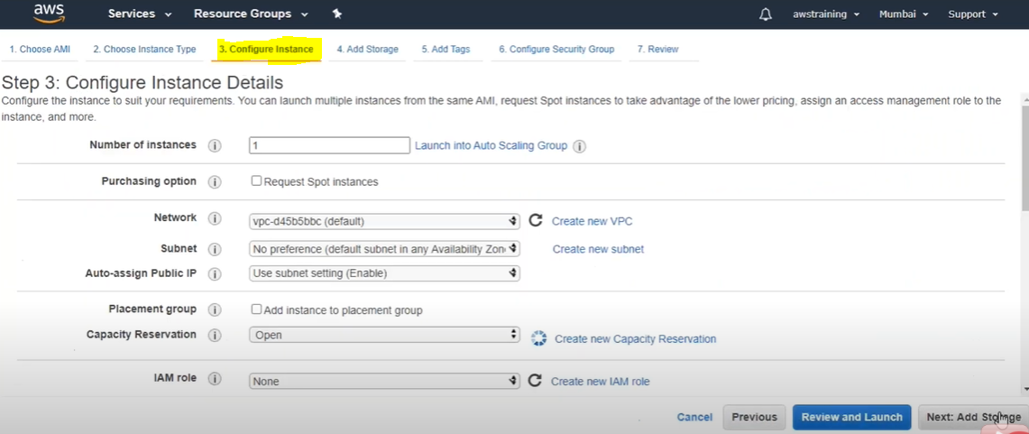

Here we scorll down littl bit then, under Advanced Details> user data put the below commands

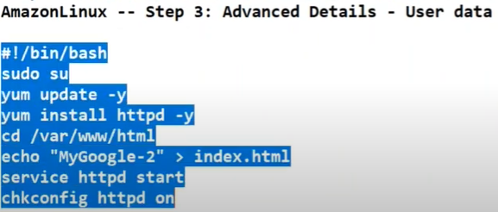

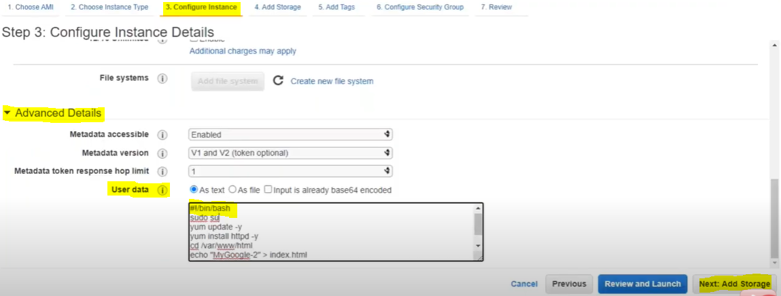

These command under this user data are called **BootStrap Script.** These commans will gets executed once the machine gets started, that is why this call BootStrap Script. So now in this case we don’t need to run the command manually in the linux machine after connecting through putty. This command will gets executed during machine startup and webserver will be created automatically.

Note2: Here in the list box we have mentioned one command on the top **[ #!/bin/bash] .** Here (#!) Is the symbol for BootStrap script and run the below command under bin/bash terminal. The bash terminal is notihing but linux terminal where the linux command gets executed/run. That is why [#!/bin/bash] comamnd need to mention on top in the user data list box.

Day-4- : Agenda 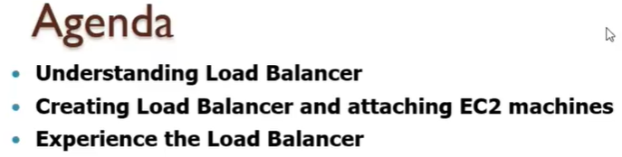

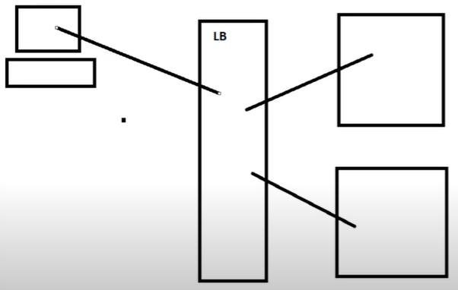

As per the above image load balancer is connected to two parallel web server, whenever used makes any request, it first goes to load balancer and load balancer based on the traffic send the request one of the parallel web server.

So load balancer manages the traffic (balance ) to avaid to down time.

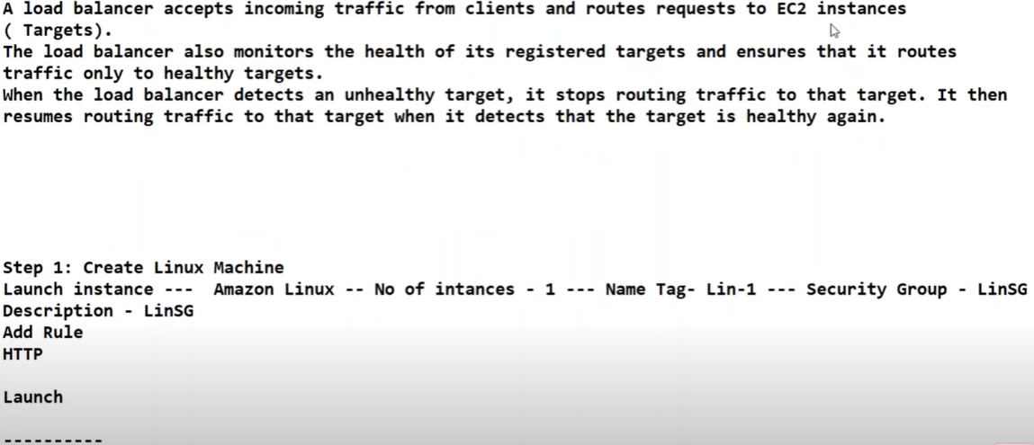

Here EC2 instances is nothing but target(web Server). So two main advantages of Load balancer

1. Distribute the traffic
2. Moniters the health of its targets

We have different types of load balancer.

1. Network LB
2. Application Level LB
3. Classic LB

Generally in AWS we use classic load balancer

Route 53 concept divert the traffic equally in all the target(web server), we can modify alos the traffic using this route 53 concept.

Load Balancer so the auto scalling of the target whenever there is heavy load in the server dynamically.

To experience load balancer we will have to fallow the followings steps

Step1- Create first EC2 machine (Windows or linux) .Fallow the above steps to create linux machine

Step2- Create another EC2 machine (Windows or linux) . Fallow the above steps to create linux machine

**Note**: 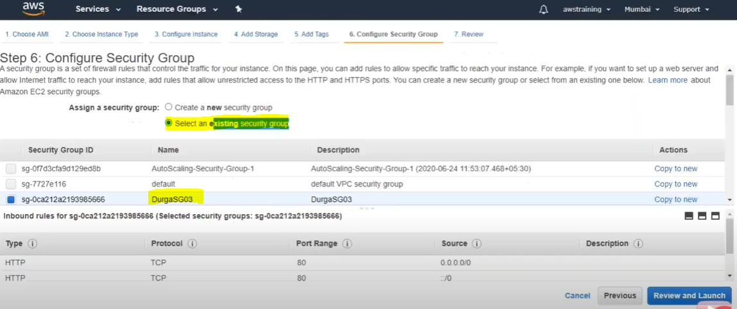

As per the above screen shot during second machine creation we don’t need create another security group name, instead we can mention the first machine SG name here for another machine also

Step3- Create a load balancer and attachet to the both the EC2 Machine.

AWS provides three types of load balencer

1. Network Load Balancer
2. Application Load Balancer
3. Classic Load Balancer

In the EC2 Dashboard itself if we scroll down then under LOAD BALANCING > Load Balancers > Click here

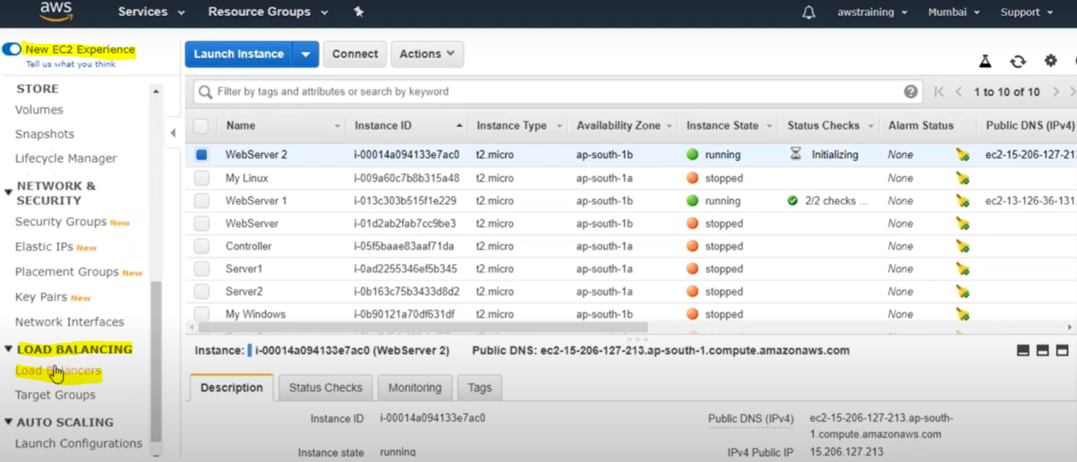

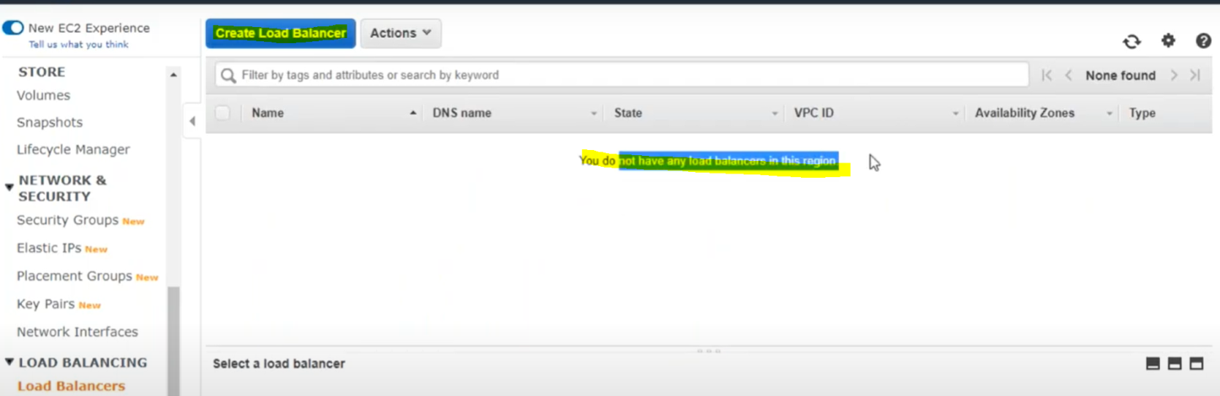

Initially we do not have any load balancer. Now click on “Create Load Balancer” to create new load balancer.

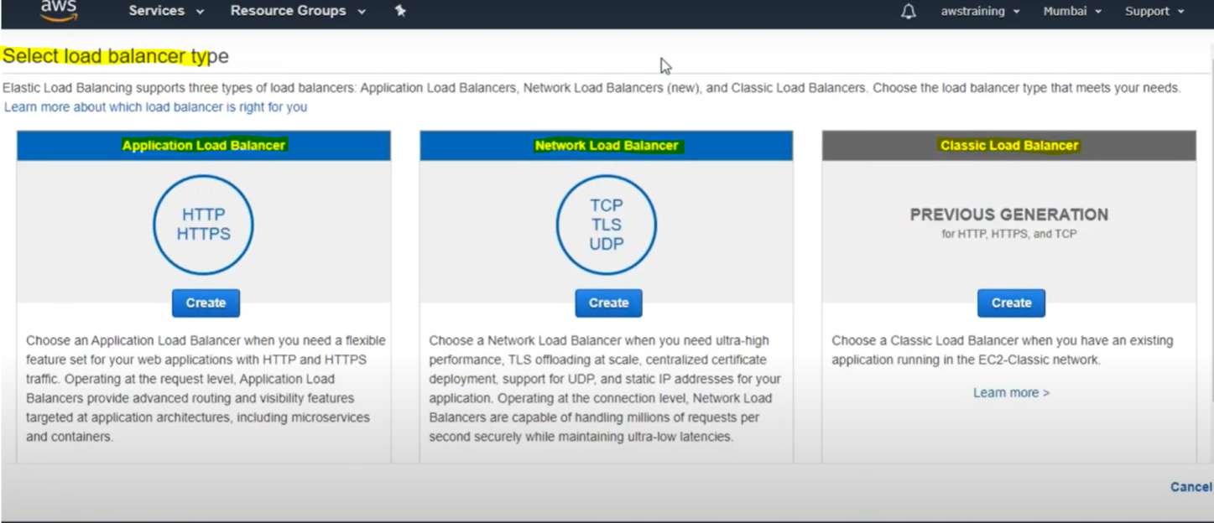

As we mentioned earlier there are three type of load balancer in AWS. Here we will create Classic Load Balancer. > Click on create

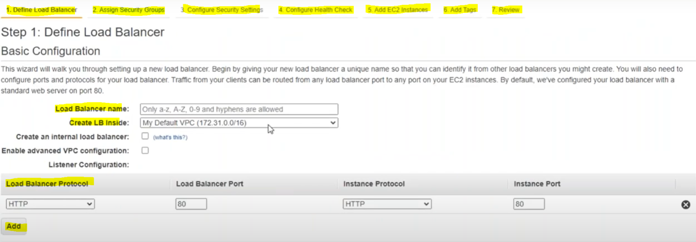

Here in this 1- Define Load Balancer ( give the name of load balancer)

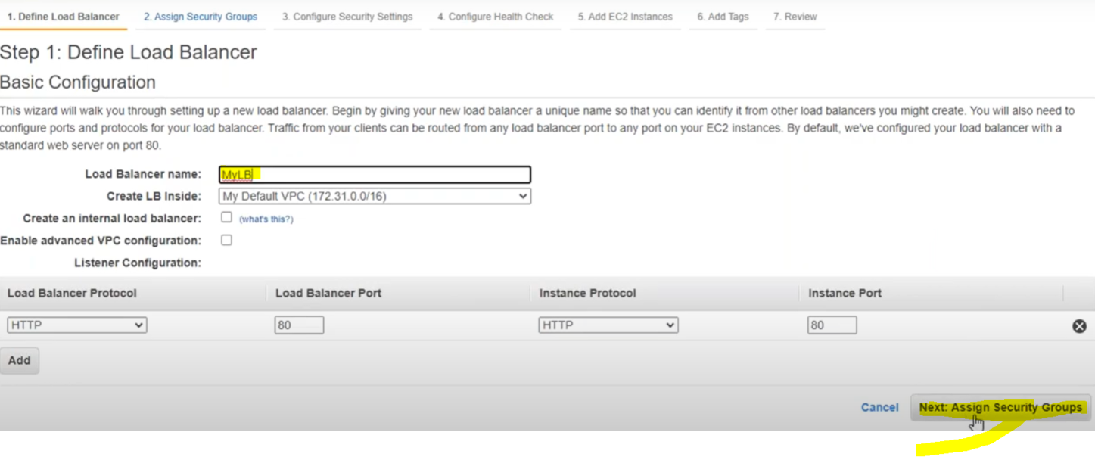

Click Next :

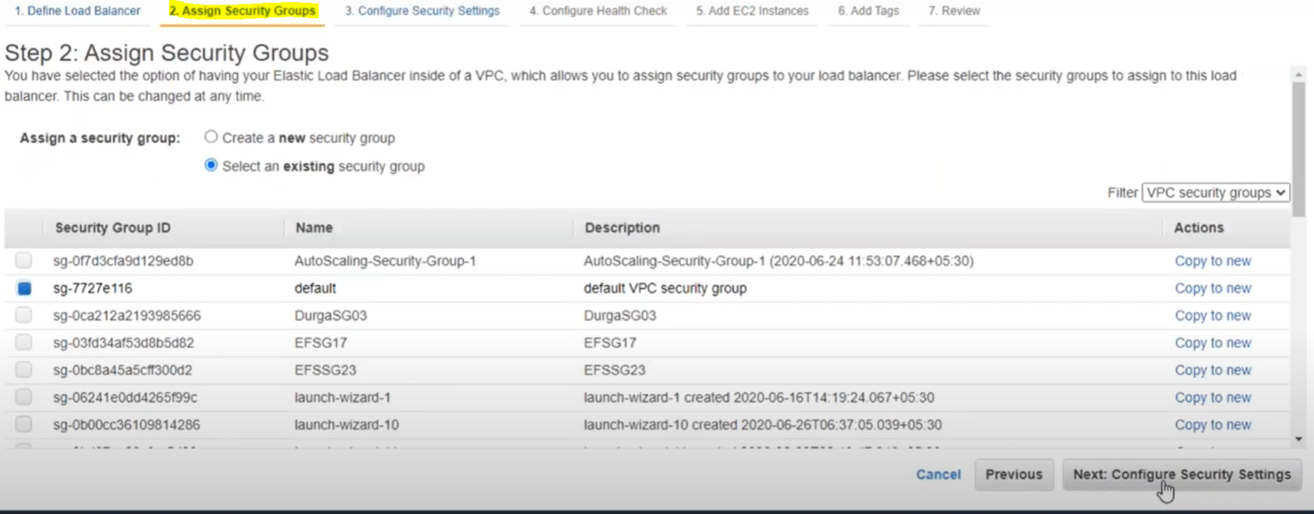

Here alos in case of Load balancer also we need to configure security group as the triffics comes first on the load balancer and here alos we will open the same port what the both target machine will have (means SSH & HTTP Port) so here we can assign the same sucurity group name what the target machine will have already

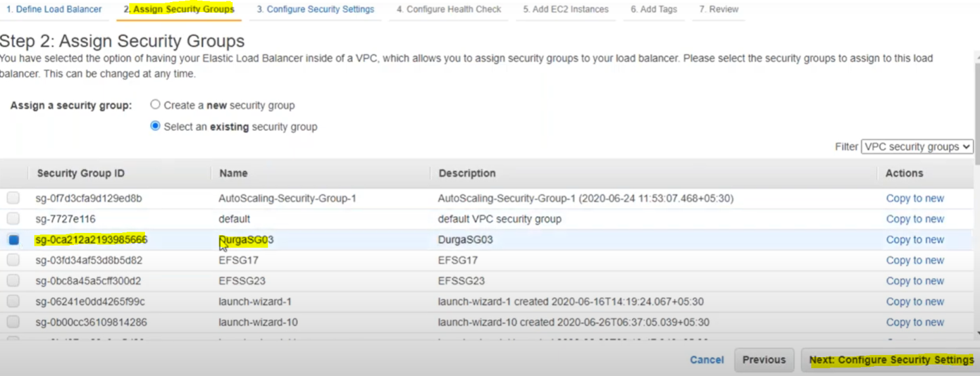

Next step is Configure Health Check:

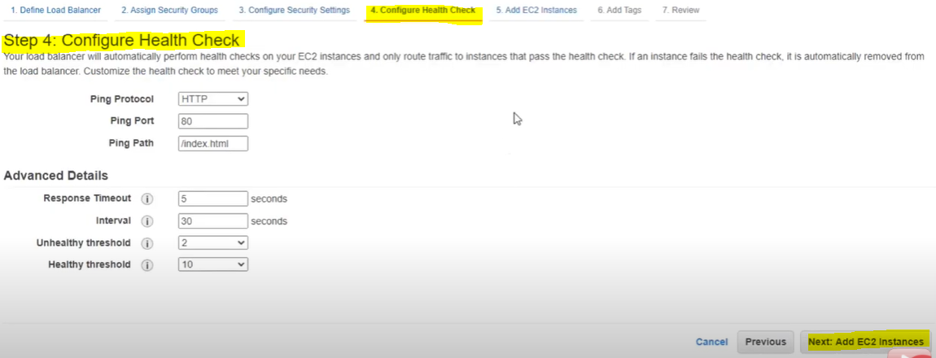

So as we have learnt earlier also load balancer have two responsibility

1. Distribute the tracfic( means as name suggest load will be balanced)
2. Another one it should monitor the health of the target EC2 machine whether they are runing correctly or not. LB sends a ping request to EC2 machine, if EC2 machine is responding, it means it is healthy, that is how it moniters the health check. So the Health Check configuration is very important

As the pet the screen shot we will have to configure

Ping Protocal,

Ping Port, and in advanced detail

Response Timeout ( means ping response),

Interval(means in every 30 second Load Balancer shoul send ping requtes to EC2 Machine,

Unhealty threshold is nothing but number of attempts or request to declare or identify the EC2 Machine is not healty means EC2 machine is not responding even after this number attempts (2)

Healthy Threshold: Let’s say machine was having some n/w issue or some other problem and now it got fixed. So now to check or veryfy the machine health the number of the request( as mentioned 10) sends to the EC2 machine is nothing but Healthy Threshold

So these are the configuraion in health check

Now next step Add EC2 Machines:

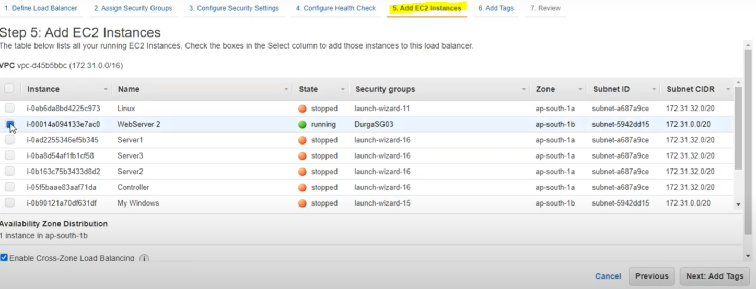

Added WebServer 1 and WebServer 2 with load balancer.

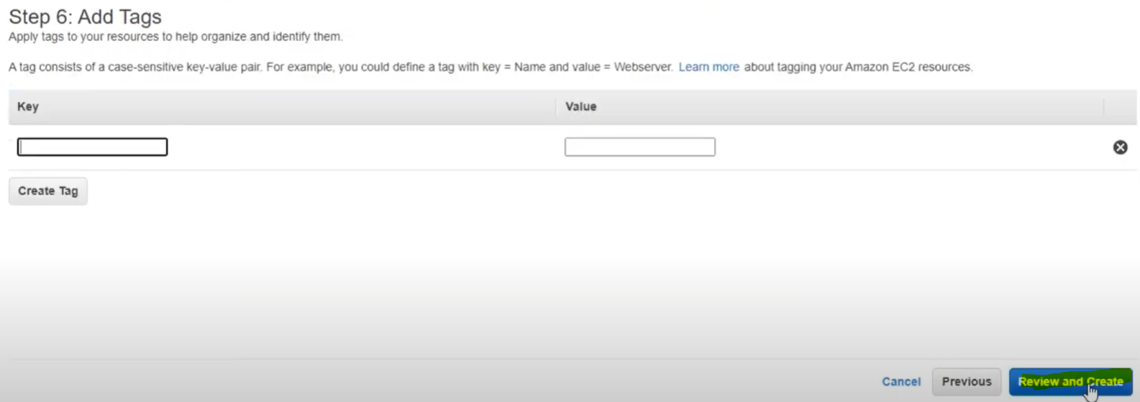

Click Review and Create.

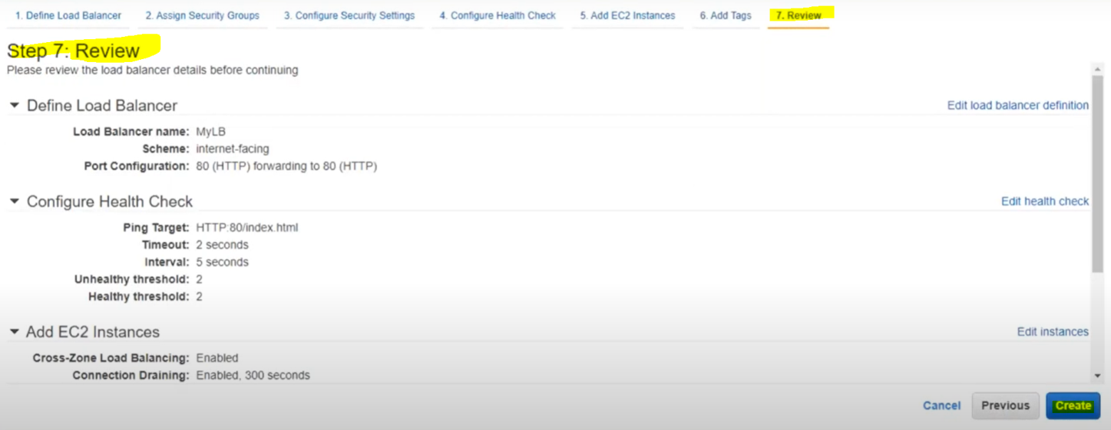

Click Create.

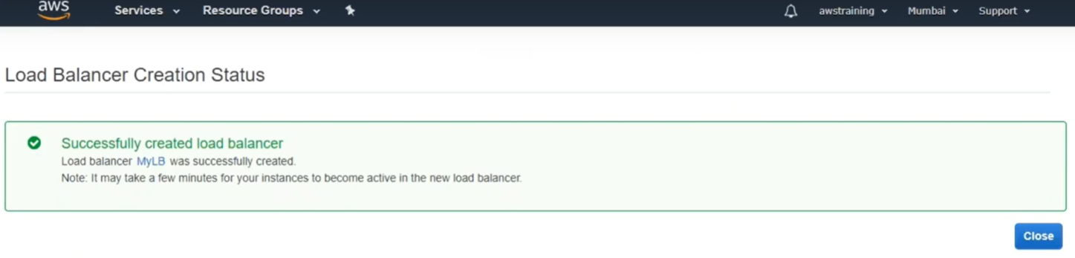

Now finally we have created load balancer sucessfully

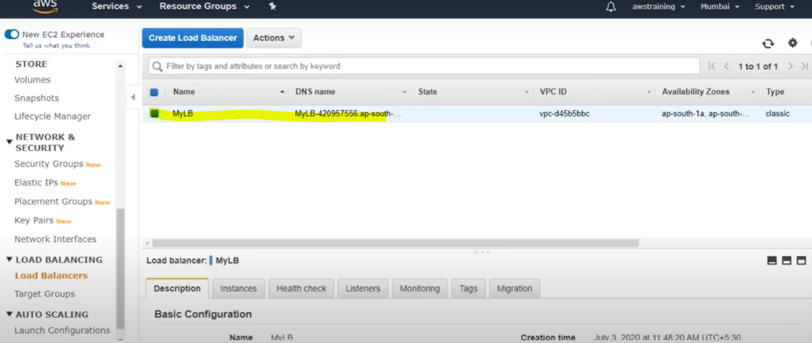

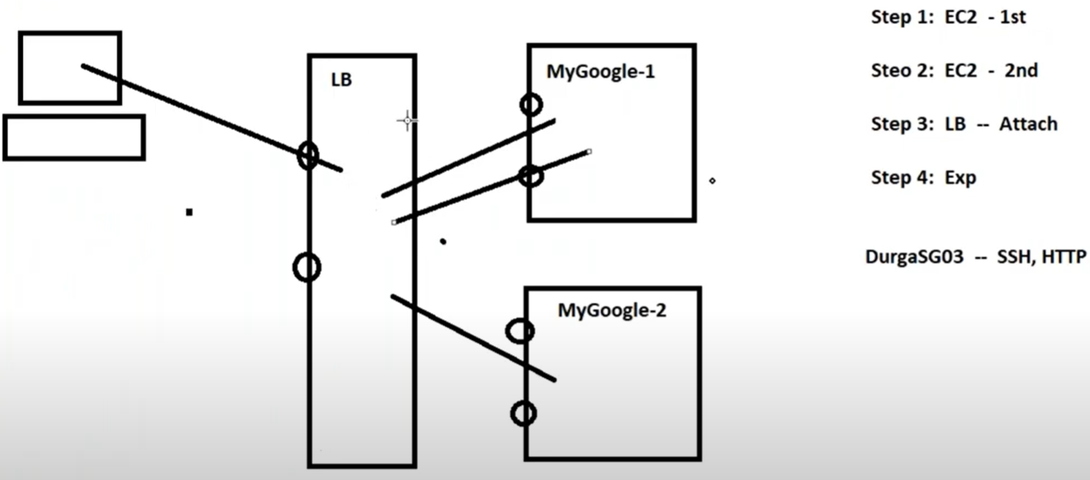

Here We have create first EC2 Machine and created one webpage having MyGoogle-1 content

Created the Security Group( Http & SSH) Port with name [DurgaSG03]

Created another EC2 Machine and creather webpage having content MyGoogle-2

Assigne the same Security Group Name for second machine also.

Created one classic load balancer

Assign the Same Security Group Name here also because Load Balancer is the one who first take the request from the outside and distribute it to the EC2 machine based on the load they have.

Connecting both EC2 machine to load balancer.

Now let’s check how the Load Balancer will distribute the balance to the EC2 machines.

Note: Any of the user for example (filpkart) they does not sends request directly to EC2 Machines. They sends request dirtely to load balancer and load balancer send these request to one of them EC2 machines. Generally load balancer DNS or IP is converted into domain name. So we should give DNS name of load balancer to public.

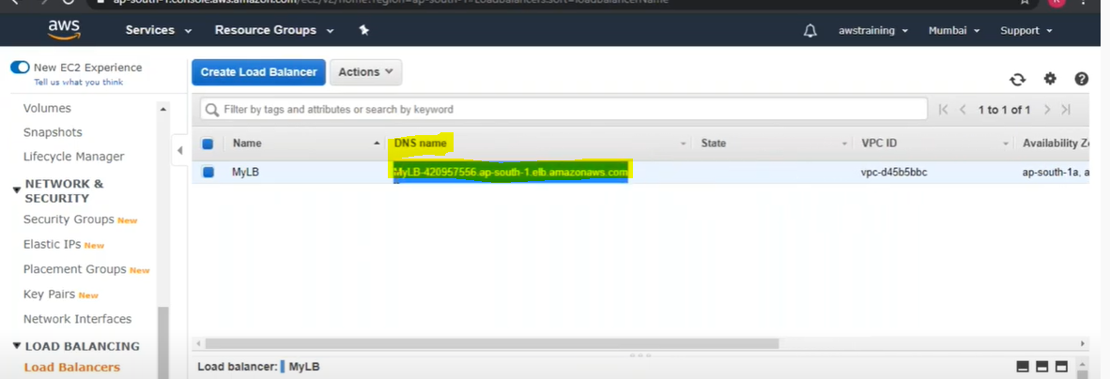

Now copy the load balancer DNS name and run in the browser.

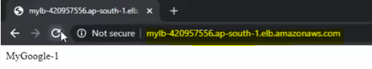

And Load balancer sends the request to first EC2 machine

Now open another browser and run the same DNS to browser.



And LB sends request to second EC2 machine

Hence LB automatically balance the traffic and sends the request to EC2 machine based on the load they have and site will not go down.

We don’t need to provide LB domain to the public, Every company would be having their own domain name that we have to link or convert with LB domain name. This conversion or linking is done by service called Route 53

Note: To remove all the instances in AWS

1. First of terminate first EC2 machine instead of stop
2. Terminate second machine instead of stop
3. Finally terminate LB from AWS

This the way to remove instances from the AWS.

So the benefit of having load balancer and copy of web server is that , if either of them gets down , even though site will not go down.